**Islamic Contributions and Achievements**

Muslim scholars were influenced by Greek, Roman and Indian culture. Many ideas were adopted from these people and formed the basis of Muslim scholarship that reached its height

during the post-classical era. Muslim achievements have had a lasting impact on the world. The following documents are related to these Muslim achievements. Examine each document and answer the accompanied questions. Keep in mind the larger question-

**What were the most important contributions Islam made to civilization?**

**Document 1**

This excerpt from the textbook World History: Patterns of Interaction (Beck, Black, Naylor, Shabaka. Evanston, IL: McDougal Littell, 1999), explains why Muslims both preserved existing knowledge and extended it.

Muslims had practical reasons for supporting the advancement of science. Rulers wanted qualified physicians treating their ills. The faithful . . . relied on mathematicians and astronomers to calculate the times of prayer and the direction of Mecca . . . Their attitude reflected a deep-seated curiosity about the world and a quest for truth that reached back to . . . Muhammad himself. After the fall of Rome in A.D. 476, Europe entered a period of upheaval and chaos, an era in which scholarship suffered . . . In the early 800's . . . the House of Wisdom opened in Baghdad. There, scholars of different cultures and beliefs worked . . . translating texts from Greece, India, Persia, and elsewhere into Arabic.

**Document 2**

The Islamic capital of Cordova was described by a contemporary as the "jewel of the world." The Islamic school and universities were preferred by European scholars such as Abelard and Roger Bacon. Philip Hitti describes Cordova in *Capital Cities of Arab Islam* (University of Minnesota Press, 1973).

Beside the university library, Arab statisticians assure us the city boasted 37 libraries, numberless bookstores, 800 public schools . . . and a total population of 300,000. Its people enjoyed a high standard of living and refinement and walked on paved streets . . . --- all this at a time when hardly a town in Europe, Constantinople excepted, counted more than a few thousand inhabitants. Parisians and Londoners were still trudging on muddy, dark alleys . . .

**Document 3**

Al-Khwarizmi, a Muslim mathematician, studied Indian sources and wrote a textbook in the 800's about *al-jabr* (the Arabic word for algebra), which was later translated into Latin and used throughout Europe. Muslim mathematicians also adopted Arabic numerals from the Indians and used them in a place-value system.

135

+20

155

3*X* = 15

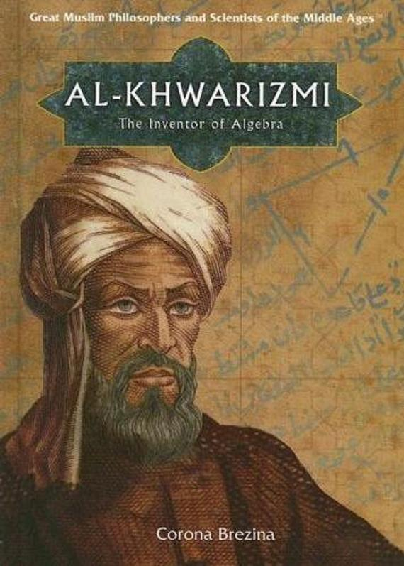

**Document 4**

Physician al-Razi wrote a medical reference encyclopedia, the *Comprehensive Book and Treatise on Smallpox and Measles.* Ibn Sina (Avicenna) wrote the five-volume *The Canon of Medicine.* These books were translated into Latin and other languages and influenced doctors in Europe. The excerpt below, taken from an Islamic medical book, and the explanation from the textbook *World History: Patterns of Interaction*, show the level of medical expertise of Islamic doctors.

Medical Reference Books

When Europeans learned that Muslims had preserved important medical texts, they wanted to translate the texts into Latin. In the eleventh century, scholars traveled to libraries in places such as Toledo, Spain, where they began translating--- but only after they learned to read Arabic.

Through this process, European medical schools gained access to vital reference sources such as al-Razi's *Comprehensive Book* and Ibn Sina's The *Canon of Medicine*. Ibn Sina's five volume encyclopedia guided doctors of Europe and Southwest Asia for six centuries. For nearly 500 years, al Qasim's work, *The Method*, which contained original drawings of some 200 medical tools, was the foremost textbook on surgery in Europe.

Document 5

Document 5

**Document 5**

Using scientific observation and their understanding of mathematics and optics, Muslim scholars made advancements in trigonometry and astronomy as well as mapmaking. They used the astrolabe and the armillary sphere to study the skies and make calculations for their calendars and maps.

Astrolabe

Armillary Sphere

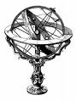

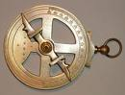

**Document 6**

Muslim artists used calligraphy and arabesque patterns to decorate buildings and objects of art as well as to reflect the glory of Allah. Calligraphy was used as religious art because creating likenesses of humans was forbidden by Islamic teachings.

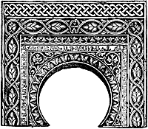

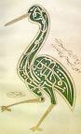

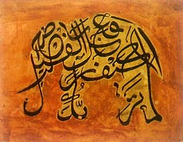

**Document 7**

Muslim architects blended features from various sources, including the Byzantine Empire, as well as added new features. The photo of the Dome of the Rock in Jerusalem is an example of Muslim architecture and the interior photo of the Mosque of Cordoba shows the geometric arabesques patterns characteristic in Islamic architecture.

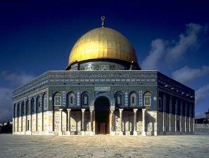

Dome of the Rock in Jerusalem

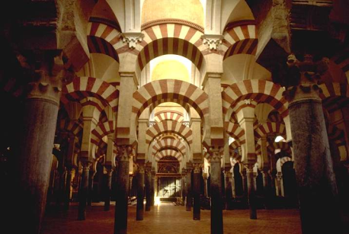

Mosque of Cordoba

**Document 8**

The standard for Arabic literature and poetry is the Quran, which influenced Sufi poets. Rumi is one of the great spiritual masters and poetical geniuses of mankind and was the founder of the Mawlawi Sufi order, a leading mystical brotherhood of Islam. If there is any general idea underlying Rumi's poetry, it is the absolute love of God. Rumi had a profound influence on thought, literature and all forms of aesthetic expression in the world of Islam.

In the name of the Merciful and Compassionate God. That is the Book! There is no doubt therein. . . God, there is no God but He! He will surely assemble you on the resurrection day . . . *Qu'ran*

As salt resolved in the ocean

I was swallowed in God's sea . . .

*Jalal al-Din Rumi --- Persian Poems*

Many of the faults you see in others, dear reader, are your own nature reflected in them. As the Prophet said, 'The faithful are mirrors to one another'.

Sources: [Breathing Truth](http://www.amazon.co.uk/exec/obidos/ASIN/0952972506/greecethracemino/) Quotations from Jalaluddin Rumi   
Muriel Maufroy, (1997)

This excerpt, by Professor Waller Hastings at http://www.northern.edu/hastingw/arabnights.htm give some insight into Muslim literature.

*The Arabian Nights* (Arabic: *alf laila walaila* (“the thousand and one nights”)) is the most famous literary product of a classical Islamic civilization that was formed through a merging of Arabic culture (especially religion) and “the great imperial traditions of the eastern Mediterranean and the Persian empire of the Sassanians” (Mack 1351).  Ironically, though, the work was not widely accepted as serious literature by the intellectual and literary elite of the Islamic world.  This rejection reflects the Koran’s condemnation of fictional narratives as “lying”; most traditional Arabic narrative was didactic or religious – history, useful knowledge, moral instruction.  Imagination and fantasy were more commonly expressed in poetry, which had a tradition in Arabic life pre-dating Islam and was not constrained by religious concerns.  *The Arabian Nights* has often been banned by Arab governments, even as recently as 1989 when Egypt issued a ban (Mack 1514).

**Document 9**

Between 750 and 1350, the Muslim merchants built a trade network throughout their empire, as this excerpt from *The Gates of India* by Sir T. H. Holdich (London: MacMillian, 1910) explains.

Masters of the sea, even as of the land, the Arabs spread throughout the geographical area. The whole world was theirs to explore . . .their ships sailed across the seas even as they moved across the land [Sahara Desert into West Africa]. The might of the sword of Islam carved the way for the slave owner and the merchant to follow.