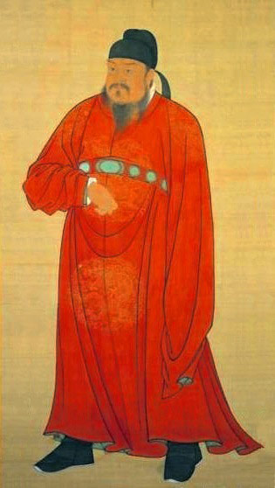
TANG DYNASTY
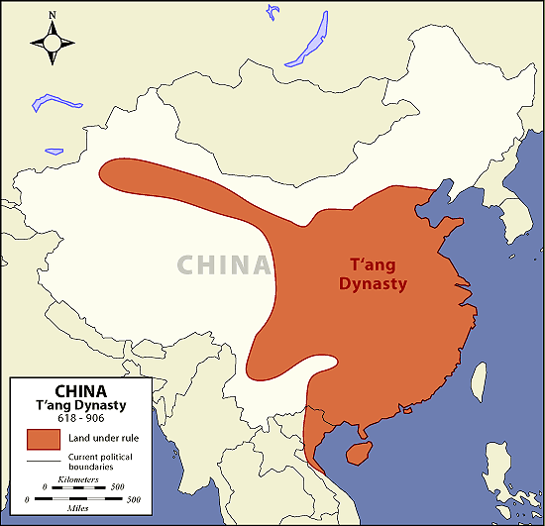
The Tang Empire was noted as a center for foreign exchange in goods and ideas, a powerful expansionist military, a capable civil service and system of education, and an explosion of arts and culture. When the Tang dynasty came to power the empire instituted many changes in Chinese government and society to strengthen and further unify China. The second Tang emperor, revived and expanded the practice of choosing government officials through rigorous written examinations that emphasized Confucian values of loyalty and service. This would be especially important as the empire expanded, making it necessary for officials to serve far from the capital city.
The Tang rulers tried to expand their holdings as far as possible by placing military bases along the Silk Road. These outposts brought new products and ideas into China from as far away as Persia and Byzantium. Increased trade and contact with foreign cultures led to the introduction of religions and philosophies from abroad. In addition to the native religious philosophies of Daoism and Confucianism, some foreign religions also became popular. The most important of these was Buddhism which spread along the Silk Road into China from India.
During the tenth century, Tang rule was weakened as a result of invasions of nomadic peoples on their northern and western borders and internal political struggles. Further, China’s government began to lose control of the Silk Road. Heavy taxes and imperial and administrative corruption finally caused rebellion, and in 907 the last Tang emperor was overthrown.

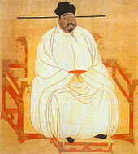
SONG DYNASTY
The Song dynasty was the second great medieval period in China. Unlike the Tang period, however, the Song dynasty constantly faced the threat of invasion. The Song dynasty built on many of the Tang’s accomplishments but life for the Chinese in this period was different. The security of the Song empire was threatened by invaders on its northern and western borders making foreign interaction in the Song more dangerous. Many Chinese responded to these invasions by often turning away from foreign goods and ideas and focusing instead on philosophies and experiences closer to home. Instead of expanding and controlling a far-flung empire like the Tang, the Song focused on increasing prosperity and stability at home.
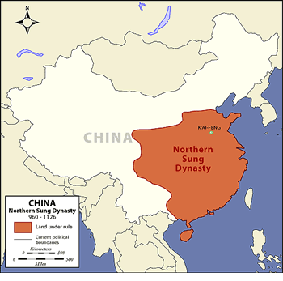
The Song dynasty placed great value on diplomacy and civilian-controlled government. Examination as a means to obtaining official government positions became even more important during the Song dynasty. But the Song dynasty suffered a blow in 1127 when neither bribes nor military defenses could prevent the Jurchen peoples of Central Asia from invading. The Song administration and many of the Chinese people retreated to southern China and established a new capital. The dynasty after this relocation has come to be referred to as the Southern Song. But even after this defeat, scholars, artists, scientists, and engineers continued to thrive in the Southern Song period. Cut off from the Silk Road in the north,
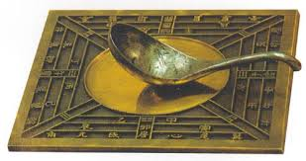
China turned to ocean-going trade. The magnetic compass allowed mariners to sail for longer distances. Constantly on the defense from outside attack, the Song developed gunpowder technology to create flame-throwers and explosive rockets The ever-present threat of invaders from the outside made many Song Chinese turn away from Buddhism and focus on reviving the native values of Confucianism. One result of this was the weakening of women’s autonomy and rights due to Confucius’ philosophy that stressed women’s obedience and dependency on men. Southern Song urban centers flourished until 1276, when the last Song regent surrendered to the Mongol forces

