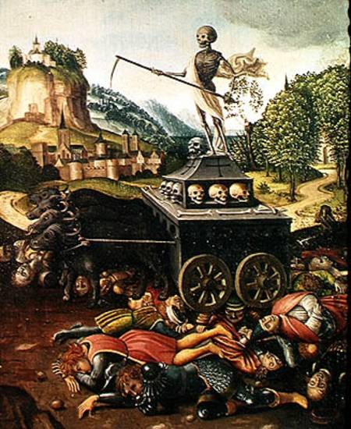
The bubonic plague, or Black Death, most likely originated in Asia. In the 14th century, this disease killed about one-third of the population of Europe and brought about major political and social change. Unlike catastrophes that pull communities together, this epidemic was so terrifying that it ripped apart the very fabric of society.
The Black Death Symptoms, or signs, of the plague included fever, vomiting, fierce coughing and sneezing fits, and egg-sized swellings or bumps, called buboes. The term “Black Death” probably came from these black-and-blue swellings that appeared on the skin of victims.
The dirty conditions in which people lived contributed significantly to the spread of the bubonic plague. The bacteria that caused the disease were carried by fleas that fed on the blood of infected rodents, such as rats. When the rats died, the fleas jumped to other animals and people. During the Middle Ages, it was not unusual for people to go for many months without a change of clothing or a bath. Rats, covered with fleas, often roamed the floors of homes looking for food. City streets were filled with human waste, dead animals, and trash.
At the time, though, no one knew where the disease came from or how it spread. Terrified people falsely blamed the plague on everything from the positions of the planets to lepers and to Jews.
Persecution of the Jews did not begin with the plague. Prejudice against Jews had led the English government to order all Jews to leave the country in 1290. In France, the same thing happened in 1306 and again in 1394. But fear of the plague made matters worse. During the Black Death, many German cities ordered Jews to leave. This skeleton appears on a gravestone dating from the Middle Ages. When the plague hit Europe people were surrounded by the dead and the dying, and this was reflected in the objects they created.
The Impact of the Plague The plague took a terrible toll on the populations of Asia and Europe. China’s population was reduced by nearly half between 1200 and 1393, probably because of the plague and famine. Travelers reported that dead bodies covered the ground in Central Asia and India.
Some historians estimate that 24 million Europeans died of the plague—about a third of the population. The deaths of so many people sped changes in Europe’s economic and social structure, which contributed to the decline of feudalism. The effects were enormous.
The town populations fell along with the amount of trade.
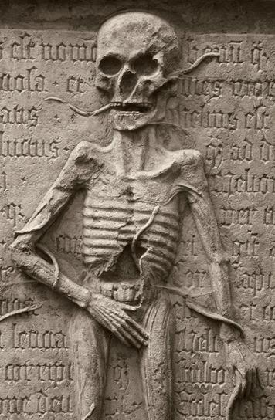
Trade and commerce slowed almost to a halt during the plague years. As Europe began to recover, the economy needed to be rebuilt. But it wouldn’t be rebuilt in the same way, with feudal lords holding most of the power.
After the plague, there was a shift in power from nobles to the common people. One reason for this was a desperate need for workers because so many people had died. The workers who were left could, therefore, demand more money and more rights. In addition, many peasants and some serfs abandoned feudal manors and moved to towns and cities, seeking better opportunities. This led to a weakening of the manor system and a loss of power for feudal lords.
After the plague, a number of peasant rebellions broke out. When nobles tried to return things to how they had been with the feudal system, resentment exploded across Europe. There were peasant revolts in France, Flanders, England, Germany, Spain, and Italy.

