The Great Schism
At the beginning of the 1300s, the Age of Faith still seemed strong. Soon, however, both the pope and the Church were in desperate trouble.
Pope and King Collide
In 1300, Pope Boniface VIII attempted to enforce papal authority on kings as previous popes had. When King Philip IV of France asserted his authority over French bishops, Boniface responded with an official document. It state that kings must always obey popes.
Philip merely sneered at this statement. In fact, one of Philip’s ministers is said to have remarked that “my master’s sword is made of steel, the pope’s is made of [words].” Instead of obeying the pope, Philip had his henchmen break into Boniface’s home to arrest him and take him to France to stand trial. Their kidnapping plot was ruined, however, when the pope was rescued by his friends. Humiliated, the elderly Boniface died a month later. Never again would a pope be able to force monarchs to obey him.
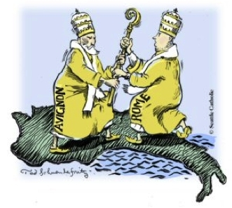
Avignon
Two years after Boniface’s death, a French archbishop was chosen as the new pope. Clement V, the newly selected pope, moved the papal headquarters from Rome to the city of Avignon in France where the papacy remained for the next 69 years.
The move to Avignon badly weakened the Church. English, Germans, and Italians accused the pope and the cardinals, who were also French, of being puppets of the French king. When reformers finally tried to move the papacy back to Rome, however, the result was even worse. In 1378, the College of Cardinals met in Rome to choose a new pope after the previous one had died. As they deliberated, they could hear an angry mob outside screaming, “A Roman, a Roman, we want a Roman for pope, or at least an Italian!” Finally, the cardinals announced to the crowd that an Italian had been chosen: Pope Urban VI. Many cardinals regretted their choice almost immediately. Urban VI’s passion for reform and his arrogant personality caused the cardinals to elect a second pope a few months later. A few months later, the French cardinals declared the election unacceptable and they elected a new pope. They chose Robert of Geneva, who spoke French, and he took the name Clement VII.
The Great Schism
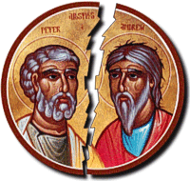
Now there were two popes. Each declared the other to be a false pope, excommunicating his rival. The French pope lived in Avignon, while the Italian pope lived in Rome. This began the split in the Church known as the Great Schism.
The Great Schism continued after the original rival popes died and each camp elected a replacement instead of working to heal the break in the church. Religious life suffered. With two sections of Christendom each declaring the other lost, each cursing and denouncing the other, many people began to question the legitimacy of the church as an institution. The church continued to lose more and more credibility and lost its status as the most powerful institution in Europe. Power was restored to politics and the Parliament gained more strength.
The Parliament allowed for nobles to voice their opinions in political matters and gave more power to the people. The Great Schism also led to beginnings of the Reformation which was a split in the Roman Catholic Church that created the Protestant (Western) churches.

