Junks
The junk is a style of Chinese ship that came into use around 220 BCE. It was perfected during the Song Dynasty (1127-1279) and used until the 19th century. Chinese mariners used the junk for exploration, trade, and war, and to patrol their coasts against pirates. The word 'junk' was not used by the Chinese, but was a Western term based on the Malay word djong, meaning boat.
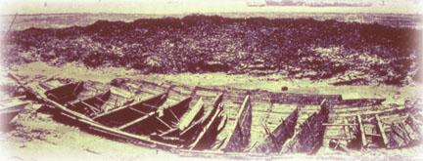
Junks were strong, heavy ships, some of which were very large. The hull was divided into watertight compartments. If one compartment began to leak, the ship would not sink. The illustration shows an example of a junk's hull with these compartments, or bulkheads. It was excavated at Quanzhou in 1974, from a muddy area that used to be a ship channel long ago. Coins from the Song dynasty dated the ship to 1272 CE.
Junks were typically made of teak, a tropical wood that is resistant to rot. Its bow was pointed, its hull had a V-shaped bottom. Twelve watertight compartments divided the hull, and also strengthened it. It had a rudder on its flat stern, but it could be lowered and raised as necessary. The inside of the hull was fitted for two masts, and there was space for a smaller one mall. A third mast had probably been fitted at the stern.
The sails of the Chinese junk were unique. They were not square-rigged, but had a curved shape that was reinforced with bamboo ribs. The bamboo made the sails so strong that they did not rot or fray as much under pressure. At the same time, the bamboo was not heavy, so less rigging was needed. These sails could be reefed (or partially drawn or folded up) like a Venetian blind. The smallest junks had one mast, and some junks had up to five masts.
Many travelers in the Indian Ocean wrote about the Chinese junks, including Marco Polo and Ibn Battuta. They confirmed details about the planking, the bulkheads, and the size of the ships, which they said could carry many hundreds of crew and passengers. The merchants, they said, could rent one of dozens of comfortable, private cabins. The crew, wrote Ibn Battuta, lived and had families on the ships, and grew vegetables in barrels. Some Chinese junks had Muslim captains from various lands, and African sailors, in addition to others.
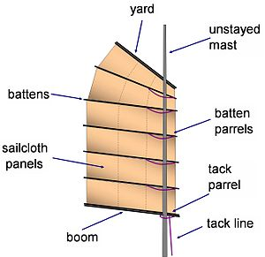

Porcelain and Silk
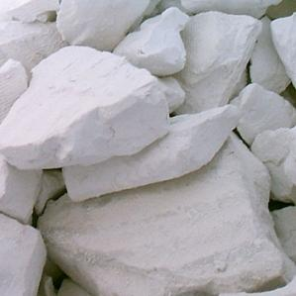
Kaolin is a rare type of clay used to make the hard, white pottery called porcelain. It is a type of rock called feldspar, which natural processes have broken down into clay. Kaolin is a form of aluminum silicate.
During the 7th and 8th centuries, the Chinese perfected techniques for mixing the clay with other substances, then forming, firing, and glazing kaolin clay to make the beautiful, white porcelain that earned it the name 'china' because it was found nowhere else in the world.
Chinese techniques of shaping, painting and glazing this fine pottery included embedding rice grains into the surface which would burn out, leaving a space in the clay that was then filled with glaze. Other famous techniques entered China from Western Asia, including the use of the metal cobalt to make bright blue glaze. Porcelain decorated with delicate Chinese and Islamic designs of clouds, geometric patterns, flowers, dragons and landscapes became a very popular trade good called blue-and-white ware.
The secret of making porcelain was not discovered by others until the 18th century, when other sources of kaolin-type clay were discovered in England. Since then, sources of kaolin have been found in many locations.
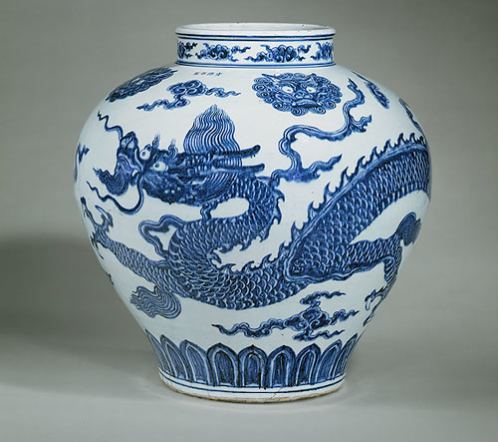
When silk was first discovered, it was reserved exclusively for the use of the ruler. It was permitted only to the emperor, his close relations and the very highest of his dignitaries. Within the palace, the emperor is believed to have worn a robe of white silk; outside, he, his principal wife, and the heir to the throne wore yellow, the color of the earth.
Gradually the various classes of society began wearing tunics of silk, and silk came into more general use. As well as being used for clothing and decoration, silk was quite quickly put to industrial use by the Chinese. Silk rapidly became one of the principal elements of the Chinese economy. Silk was used for musical instruments, fishing-lines, bowstrings, bonds of all kinds, and even rag paper, the world’s first luxury paper. Eventually even the common people were able to wear garments of silk.
Initially, silk was traded only internally within the Chinese Empire. Frequently, small Central Asia tribes would attack the silk trading caravans with the intention to capture the valuable silk commodities. It was Chang Ch'ien, one of China's greatest explorers, who initiated contact with the Central Asian tribes. He also expanded the silk trade by including the smaller Central Asian nomads. As a result, the Silk Road was born.

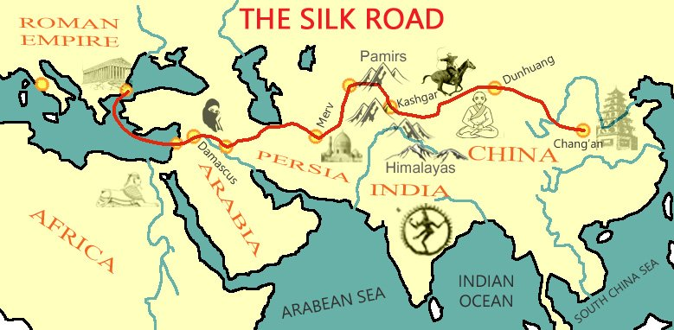
Paper
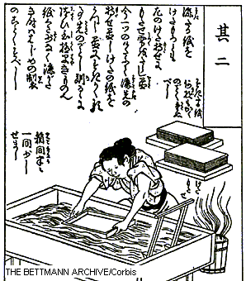
Paper is a common item in every household today, and even more in offices and schools around the world. Paper is an invention that shouldn't be taken for granted. Before paper, people wrote on clay, stones, bones, and leather. In Egypt, they used papyrus, from which Western languages got their name for paper, by pounding strips of reeds together. Papyrus is very brittle, however, and not suitable for books. In China, bamboo and silk were useful but impractical. Parchment is made from beaten sheepskins, and is both thick and expensive. Killing a flock of sheep to publish a book is an expensive thing to do. Paper was invented, according to Chinese sources, by a man named Ts'ai-Lun, in China in about circa 105 CE. There is evidence from archaeology, however, that paper was used at least a century earlier in China. The technology of making paper developed as plentiful plant fibers were used to make quantities of paper cheaply.
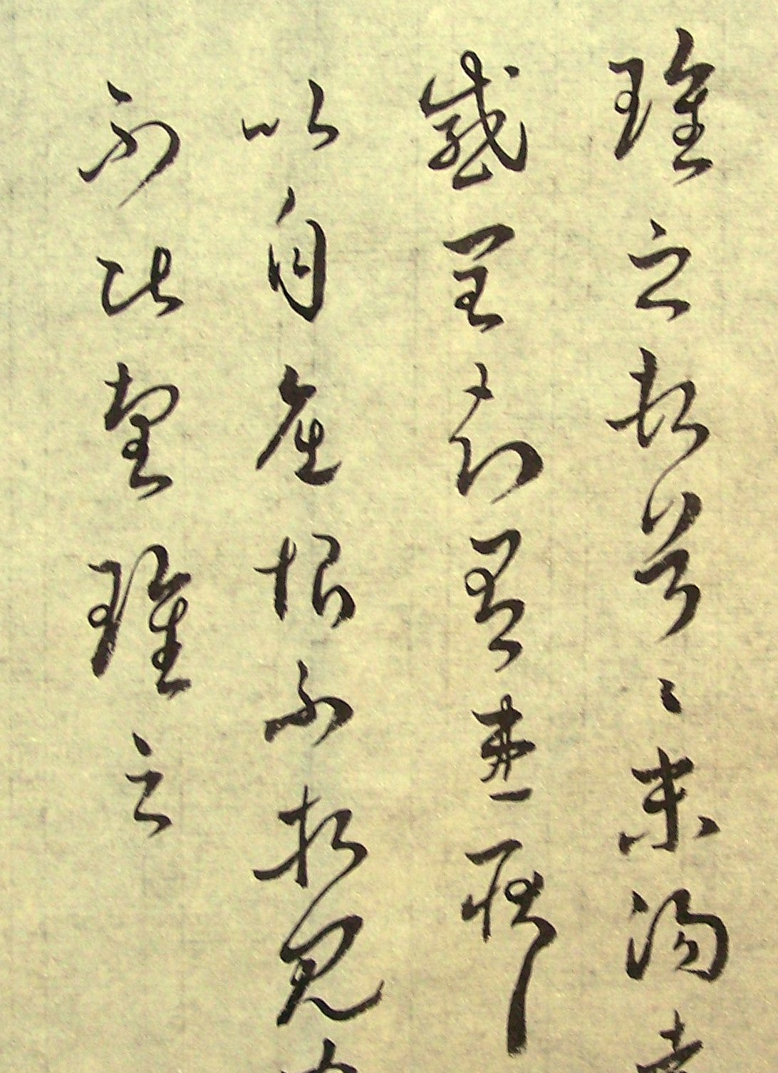
The basic concept of making paper is to pound plant fibers into pulp, a mash of fibers. Mulberry tree bark, rice stalks, cotton fiber and old rags were among the fibers used in China. The fibers were then mashed together and suspended in water, making a thick slurry. A frame covered with cloth was dipped into the fiber bath, shaken to distribute the fibers across the frame, and the water strained out, as the first image from Korea shows. The fibers fused together, and when it was dry, a sheet of paper could be taken off the frame. Later, bamboo matting was set loose in the frame, so that the mat and the paper could be taken off the mat before it was dry, and the mat could be re-used quickly. This sped up production.

Process of making paper
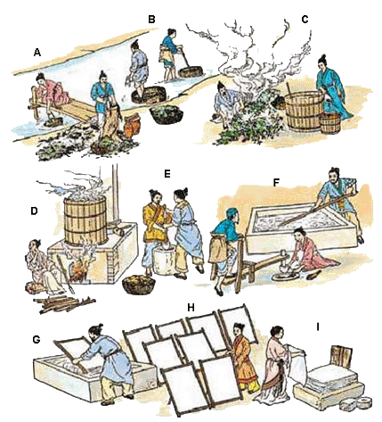

Movable Type
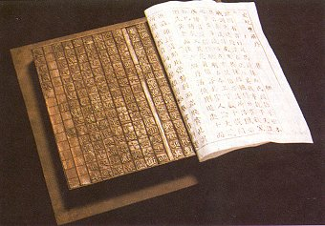
The availability of a durable and cheap material such as paper made it possible to communicate and transmit ideas over long distances as well as record information for future generations. But the act of writing by hand was slow and the knowledge was also limited to only the elite: religious clergy, nobility, and royalty. To make producing books easier and faster the Chinese invented block printing and moveable type. With block printing, Chinese characters were carved onto a wooden block which could be used to print an entire page at a time. With moveable type, the characters were carved onto small individual blocks which could be moved around to make it easier to quickly print entire books. The first printed newspaper, Kaiyun, was started during the Tang Dynasty in 713. In 868, Wang Jie printed a copy of the Diamond Sutra, which is the oldest printed book in existence. By the 11th century, alchemist Bi Sheng, began working with movable type. Printed books replaced scrolls and there's evidence of color printing from China as early as the 14th century. Inventions such as the printing press spread from east to west across the trade routes known as the Silk Road. As papermaking moved from China to Korea, Japan, and Central Asia, other plants were used.
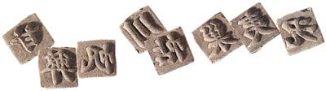

Paper Money
China is not only credited with having invented paper but it is also the first in the world to use paper money. True paper money became a major form of currency during the Northern Song Dynasty (960-1127).
The use of paper currency was initiated by merchants. To avoid having to carry thousands of strings of coins long distances, merchants in late Tang times (c. 900 CE) started trading receipts from deposit shops where they had left money or goods. The early Song authorities awarded a small set of shops a monopoly on the issuing of these certificates of deposit, and in the 1120s the government took over the system, producing the world’s first government-issued paper money.
Paper money had two main advantages over money made out of silver, gold, copper or iron: It was easier to carry around and the copper and iron could be saved for use in everyday objects. Chinese paper money is more than just a convenient a form of currency. Pictures, called vignettes, were originally added to the design of paper money as a measure against counterfeiting.
When Macro Polo traveld to China in the 13th century, he was so impressed by paper money that he described how it was made, used and valued. Paper money was not used in Europe until the 17th century.
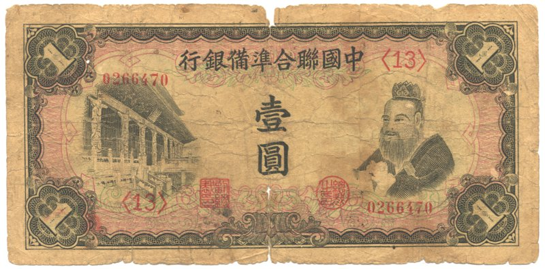

Gunpowder
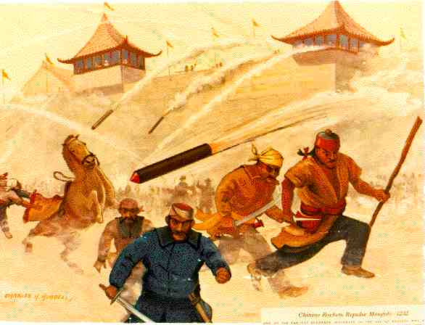
Chemistry began as a magical and spiritual art called alchemy. The word alchemy comes from Arabic language. Alchemy developed into a science as those who practiced it wrote down their observations and results, and were able to communicate and reproduce the same results over and over. Alchemists tried to learn about different substances by purifying, pulverizing, and heating them under controlled conditions. They experimented with sulphur, a mineral, and saltpeter (potassium nitrate), which came from decomposing organic matter - dung heaps, to be exact. It could also be scraped from cave walls.
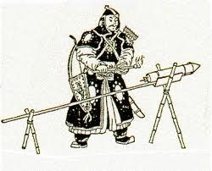
Combining these two common substances with charcoal produced an explosive material. Learning to control the explosion was the difficult part, so alchemists experimented with different recipes. The basic concept is to combine a fuel (charcoal or sugar), and oxidizer (saltpeter), and sulfur (to make the reaction stable). Together, the carbon in the fuel combines with oxygen (the combustion), and saltpeter adds extra oxygen (rapid combustion). The saltpeter also reacts with the carbon to form expanding gases (the explosion). Gunpowder can produce smoke, or it can work as a propellant (to shoot something like a rocket), or it can produce a visible display of sparks and fire. Accounts of fireworks - both noise and light - go back about 1000 years in China.
Though there is some evidence of early Chinese experiments during the Han dynasty, gunpowder developed during the 8th century (Tang dynasty 618-907 CE or the Song 969-1279 CE). Several Chinese books about gunpowder exist from around this time. The recipe was called huoyao or gunpowder. Its use as a weapon and source of entertainment as fireworks developed gradually. Its explosive power was harnessed by using tubes into which arrows could be placed. It was also used as a battlefield smokescreen against the Mongols, and the Chinese used gunpowder to fire rockets, or gunpowder filled bamboo tubes containing arrows. The image above shows Mongol forces using explosives against invading armies.
The path of transmission toward the west may have occurred by land, or by sea. During the Crusades, Arab and Turkish forces used a type of grenade in ceramic pots. In Granada by the 1400s, gunpowder was being used to fire projectiles. From the Mediterranean area, gunpowder weapons spread to Turkey, to Italy, and on into Northern Europe.

Footbinding
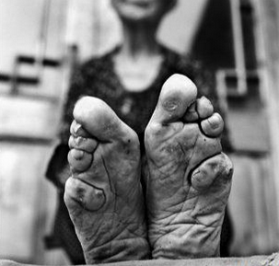
Foot-binding is believed to have begun during, or just before, the Song Dynasty in China around the 10th Century, and became widespread within a couple of hundred years. Bound feet were seen as a status symbol for wealthy women who did not need to work, although eventually the practice became widespread. Footbinding is a long and painful process, produced tiny feet in women. Modern people may find it hard to understand, but the reasons for footbinding went deeper than fashion and reflected the role of women in Chinese society and Confucian moral values for women of domesticity, motherhood, and handwork. It was necessary for a woman to have bound feet in order to marry well and achieve a good and moral life.
Folklore says the practice started when a royal concubine had her feet bound because her prince loved her little feet and her ability to dance and walk so gracefully that she appeared to be “skimming over the top of golden lilies,” and others copied this desirable look. It may also have developed from popular dances that came to China during the Tang dynasty (618–907) from western regions along the Silk Road. Richly embroidered slippers also came to China at this time. The lotus, the sacred flower associated with Buddhism, became associated with the small shoes.
Motherhood was an ideal role for Chinese women, and a mother’s goal for a daughter was a good marriage. Mothers bound their daughters’ feet, beginning between about five and seven years of age. All toes except the big toe were folded under the foot and pulled back toward the arch, held in place by a long strip of cloth, creating a steep, concave arch and fold in the center of the sole. The front of the heel bone was pushed up, and the top of the foot became rounded and steeply angled. Because the cloth bindings were worn night and day and only removed for cleaning the foot, some muscles and tendons became stretched and some contracted, forcing bones into different positions and resulting in a reshaped or deformed foot that was shorter and had a narrower sole. The process was very painful and after it spread to the lower classes, meant that daughters could not perform the most strenuous field tasks. Walking changed to a shuffling gait. After body growth stopped, binding continued throughout life because the cloth strips and specially shaped shoes were necessary for support of the foot. Footbinding was associated with another important role of Chinese women, domestic production of textiles, and the making of shoes.
It was not until the revolution of 1911 that the process was banned, yet some in rural areas continued the tradition for decades to come until the bandages were forcibly removed leaving the feet disfigured.
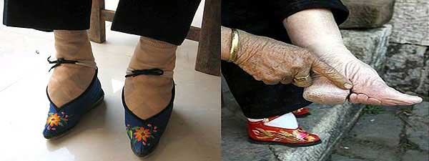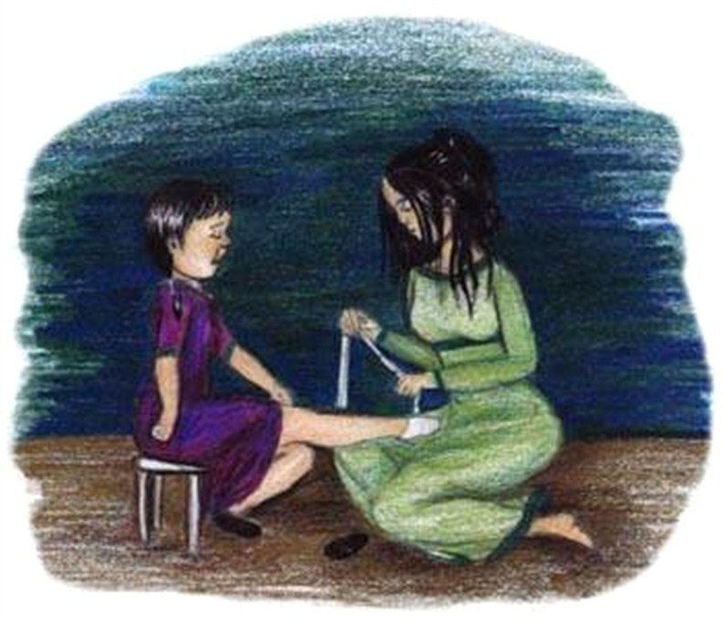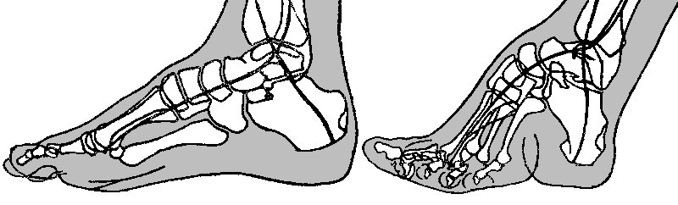

Neo Confucianism
Confucianism had been the dominate ideology and philosophy in China since the Han dynasty. It was founded by an ancient Chinese philosopher, Confucius (551–479 BCE). His philosophy and teachings were constantly developed, reinterpreted, and refined by his followers throughout the course of Chinese history. The predominant theme of Confucianism is its emphasis on social ties and duties as designated in the proper behavior for "five relationships": sovereign-subject; husband-wife; parent-child; elder brother-younger brother; and friend-friend.
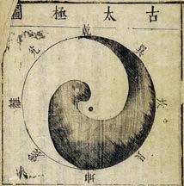
In the middle of the second century BCE, Confucianism was established as the official state ideology. However, during the Tang and Song dynasties influences from Taoism and Buddhism significantly challenged the dominant status of Confucian ideology. Confucian scholars met this challenge by integrating elements of both Taoist and other native philosophies into a single integrative ideology known as Neo-Confucianism. Neo-Confucianism can be described as the culmination of an effort to integrate and harmonize several different religious and philosophical traditions that had developed in China over the preceding thousand years, and as a way of making sense of several diverse and sometimes competing philosophies. The Confucian emphasis on principles such as “humaneness,” “filial piety,” and “ritual” was integrated with more abstract Taoist notions of a “the Way” (Tao) that governed all existence, as well numerous Buddhist principles.
"Neo-Confucianism" is a general term used to refer to the renaissance of Confucianism during the Song dynasty following a long period in which Buddhism and Daoism had dominated the philosophical world of the Chinese, and also to the various philosophical schools of thought that developed as a result of that renaissance. Neo-Confucianism had its roots in the late Tang, came to maturity in the Northern and Southern Song periods, and continued to develop in the Yuan, Ming, and Qing periods. As a whole, Neo-Confucianism can best be understood as an intellectual reaction to the challenges of Buddhist and Daoist philosophy in which avowedly Confucian scholars incorporated Buddhist and Daoist concepts in order to produce a more sophisticated new Confucian metaphysics. As Neo-Confucianism developed, two major Neo-Confucian schools of thought emerged: the School of Principle and the School of the Heart/Mind. Both schools of thought agreed that all the myriad components of the universe are manifestations of a single "Principle" (li), and both schools agreed that this Principle was the essence of morality. By understanding the Principle that underlies the universe, then, men may understand the moral principles that they must put into practice in order to achieve an ordered family, good government, and peace under heaven. The two schools differed, however, on the way in which human beings should understand Principle.

Civil Service Examination
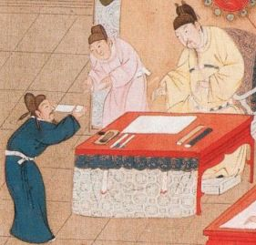
The Tang and Song dynasty took the Han system of government with the civil service examination and applied it in a much more systematic way as a method of official recruitment. They also introduced the rule that officials must be appointees of the central government rather than local aristocrats and that the local militia was to be subject to officials of the central government. The Tang dynasty (618–907) created a system of local schools where scholars could pursue their studies. Those desiring to enter the upper levels of the bureaucracy then competed in the jinshi exams, which tested a candidate’s knowledge of the Confucian Classics. This system gradually became the major method of recruitment into the bureaucracy; by the end of the Tang dynasty, the old aristocracy was destroyed, and its power was taken by the scholar-gentry, who staffed the bureaucracy. This non hereditary (not based on inheritance) elite would eventually become known to the West as “mandarins,” in reference to Mandarin, the dialect of Chinese they employed.
The civil-service system expanded to what many consider its highest point during the Song dynasty(960–1279). Public schools were established throughout the country to help the talented but indigent, business contact was barred among officials related by blood or marriage, relatives of the imperial family were not permitted to hold high positions, and promotions were based on a merit system in which a person who nominated another for advancement was deemed totally responsible for that person’s conduct.Almost all Song officials in the higher levels of the bureaucracy were recruited by passing the jinshi degree, and the examinations became regularly established affairs. After 1065 they were held every three years, but only for those who first passed qualifying tests on the local level. A meritocracy is a type of government where officials were chosen by their merit or worth. This means that people were chosen on what they could do, not by how wealthy they were. So many people wanted government jobs because they were well-respected jobs and people in these positions enjoyed privileges like being excused from paying taxes and military service.

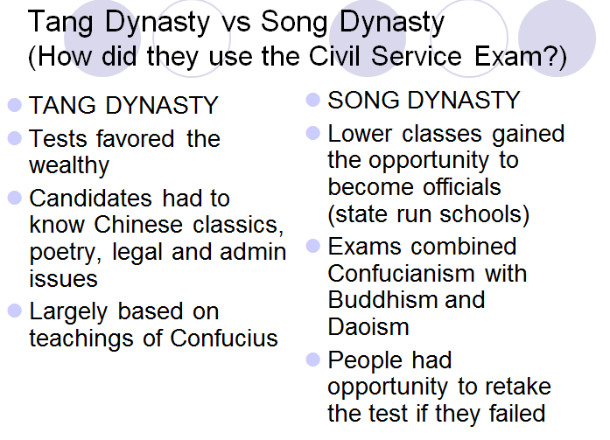

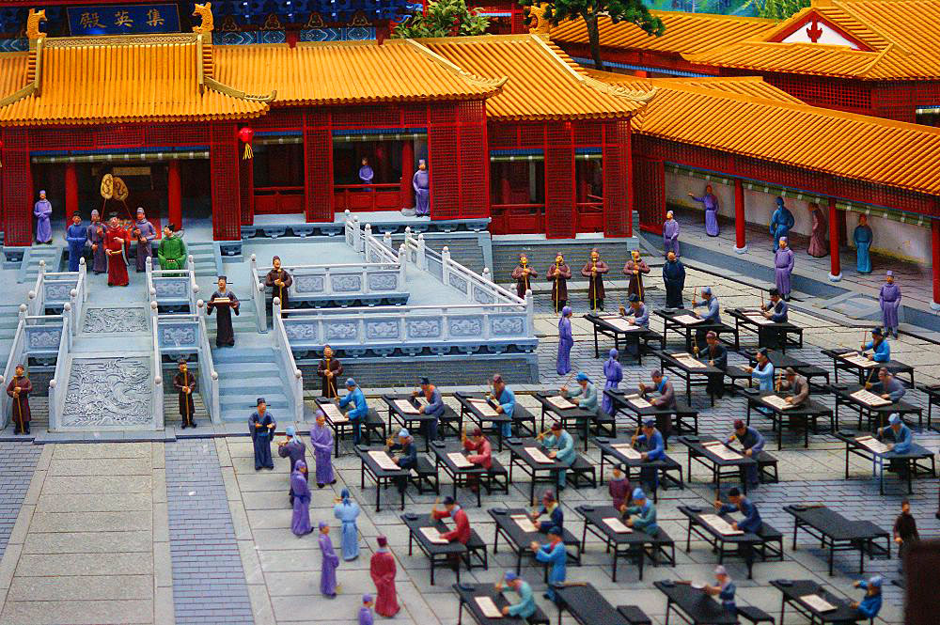

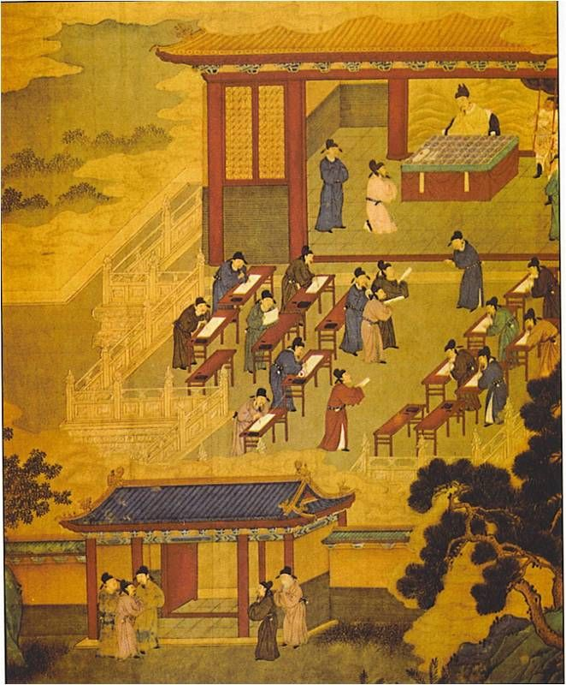
Chang’an
Chang’an was an ancient capital for more than ten Chinese dynasties and known as the famous eastern terminal of the Silk Road. Chang’an was the Chinese capital for the Han, Sui and Tang dynasty leaders.
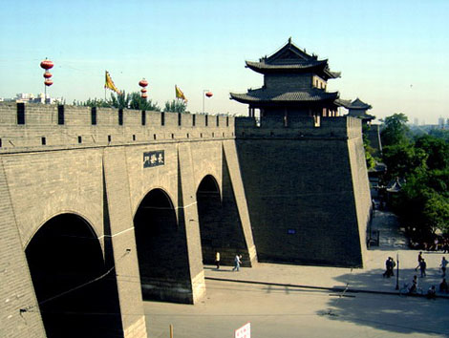
In classical Chinese history, Chang’an means “Perpetual Peace.” As the eastern terminal catering the Silk Road, Han Dynasty leaders (206 BC-220AD), the longest-lived and one of the most powerful rulers all over ancient China, launched explorations directed towards southeastern Asia, Central Asia, and eventually towards Rome.
With an area at approximately 84 square kilometers and enclosed with a 25.7 km long city wall and with a 6.13 m wide moat, this ancient capital prided on its striking buildings, particularly the temple of Heaven, a platform made from pounded earth with four concentric rings. Chang’an had been populated since way back the Neolithic times.
Overall, the ancient city took the form of an irregular rectangle, with the city’s main square twisted to mimic the Big Dipper for astrological reasons and at the same time to conform to the Wei riverbanks. Due to the mountainous country surrounding the life-nourishing Wei River basin, only two roads go south and another two to the western mountainous Gansu. This however, would form the foundation for the ancient silk routes.
The capital was also regarded as the economic, political and cultural center of ancient China. As a cosmopolitan metropolis, it was also a consumer city, whose main purpose of existence was not solely patterned upon trading and manufacturing activities. Its large population tells the story. The title of political and military center in ancient China had a direct effect that boosted the population of aristocratic nature. Dominated by scholars, whose educations were supported by their wealthy aristocratic families, it became a centralized hub of civil servants for the general welfare and improvement of ancient China.
A plethora of historical and archaeological sites are located in and around Chang’an, including such places as the Big Wild Goose Pagoda, the Forest of Stone Stele, and the Emperor’s Winter Palace at the Huaqing Hotsprings. The most famous of these, of course, is the burial site of China’s first emperor Qin Shihuang-di and his 7000 terra cotta warriors.

