**World History Fall Semester Final Review Answer Key**

**Foundations of Civilization 8000BC-500BC:**

1. Define the Neolithic Revolution and explain its impact on civilizations.

* Neolithic Revolution = Transition from hunting/gathering to agriculture (cultivation of crops/farming)
* Effects: Surplus (extra or an abundance of) crops, population growth, settled down permanently, unequal Social Structures, specialization of jobs (lots of new/different jobs), market economies based on trade emerged, enabled emergence of civilization
* 6 Characteristics of Civilization: Cities, Organized religion, government, social stratification, written language, artistic & architectural activity

2. Identify the importance of Hammurabi’s Code and the Ten Commandments.

* Code of Hammurabi: established idea of government regulation of society, first written law, an Eye for an Eye justice, treated social classes differently
* Ten Commandments: moral Code or laws followed by the Hebrews/Jews, no punishments given – set of moral behaviors more than laws - Judaism is monotheistic (believe in one God)
* Significance: first written laws – US laws influenced by Ten Commandments

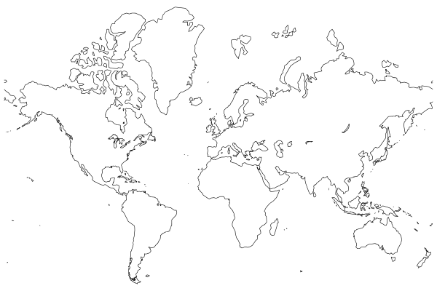3. Identify where the Indus River Valley, Mesopotamia, Chinese, and Nile River Valley Civilizations are located on a map and explain the major political, economic, and social characteristics of each civilization.

* Mesopotamia/fertile crescent/Sumerians on Tigris & Euphrates Rivers; cuneiform writing, wheel
* Egypt on Nile River Valley; pyramids, hieroglyphs

Develop calendar to track flooding patterns

* Indus River Valley (India); planned cities; plumbing system
* Huang He River/Yellow River Valley (China); rice, bronze work, character writing

**Classical Civilizations 500BC-500AD:**

4. Identify and explain the significance of the characteristics of empire.

* 7 Characteristics of Empire:
  + Common language – efficient & effective communication within the empire
  + Imperial cities – location of large markets full of trade goods; center of govt. admin.; center for arts & education
  + Ideology – justification for who is in control and for the social order; ex. Mandate of Heaven, Caste System
  + Strong military – conquer more lands, protect borders of empire, maintain order within empire
  + Strong central admin. – collect taxes, enforce laws, regulate monetary system
  + monumental structures – display of wealth & power
  + Strong economic growth – control trade routes, road systems, canals, collected taxes and tribute

5. Explain the importance of the Zhou, Qin, and Han Dynasty in China.

* 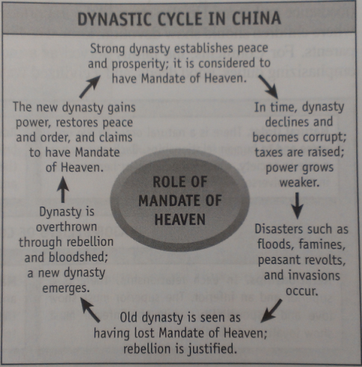Zhou Dynasty:
  + Created the Mandate of Heaven = LEGITMIZES THE RULERS RIGHT TO RULE!!!!!
  + Beginning of Dynastic Cycle
* Qin Dynasty:
  + Leader Shi Huang Di built roads and created a single monetary system in order to unify the empire
  + Legalism – order in society can only be maintained through strict laws and harsh punishment
* Han Dynasty:
  + Civil Service Exams (based on Confucian teachings) for bureaucrats; enables them to build a strong central government

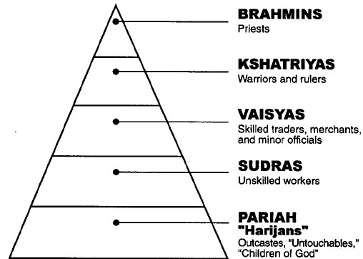6. Explain the Caste System in India.

* Hindu Social Hierarchy determined by birth; no social mobility during your lifetime
* If you do your dharma, get good karma, go up a varna (a caste) in your next life

7. Explain Hinduism and Buddhism.

Hinduism – believed in many gods, Holy book – Vedas and Upanishads, believe in Karma and Dharma, the Caste System, and reincarnation

Buddhism – Believe in the 4 Noble truths and follow the 8 fold path, believe in reincarnation and reject the Caste Systems

8. Explain Confucianism.

* Chinese philosophy that sought to create social order and good government by organizing society into five relationships – including what is expected of the inferior and superior members in each relationship
  + Ruler (good example)/Subject (loyal and obedient)
  + Father/Son
  + Husband/ Wife
  + Elder brother/younger brother
  + Elder Friend friend/younger friend

9. Identify important contributions of Greece.

* Athens (city-state of Greece) practiced direct democracy-government ruled by the people (all citizens vote on issues)
* Columns
* Philosophy
* Art
* Many legal and political principles that influenced Western governments

10. Identify important contributions of Rome.

* Strong central government
* Practice republican (representative) form of government
* 12 Tables
  + Equality before the law
  + Innocent until proven guilty
  + Right to trial by jury of peers
  + Influenced our legal system
* Roads, bridges, aqueducts
* Many legal and political principles that influenced Western governments

11. Identify the similarities and difference between the fall of Rome and the fall of the Han Dynasty in China.

Rome Han

* Ineffectual (bad) government
* High Taxes
* Lack of Tax revenue (money)
* Plagues
* Invasions-not the only reason, but the straw that broke the camel’s back
* Less people farming b/c killed by plague 🡺 higher taxes
* Armies/Wars expensive🡺 more need for taxes
* Clear line of succession
* Chinese society survived fall of Han – will make a comeback because of DYNASTIC CYCLE
* Divided into East and West
* Less people farming b/c killed by plague **🡪** higher taxes
* Huns & Visigoths invaded **🡪**Roman Empire gone forever (east reinvents self as Byzantine Empire)

**Post Classical Era 600-1450 The Islamic World:**

12. Explain the central beliefs and historical origins of Islam.

* Monotheism
* Qu’ran is the sacred text=Word of Allah (God)
* Mecca is the holy city
  + Kaaba is the holy shrine
* Mohammad = last of God’s prophet who gave the final revelation to the world
* 5 Pillars:
  + Declaration of Faith
  + Prayer 5 times a day towards Mecca; called to prayer from *minarets*
  + Charity
  + Fasting during the month of Ramadan
  + Hajj: Pilgrimage to Mecca
* Sunni-Shia split – After Muhammad died he left no successor or heir and the Muslims were split over who should be the next caliph (leader). The Shia said it should be a direct descendent of Ali (Muhammad’s relative) and the Sunni said it should be someone from the Umayyad family (dynasty)

13. Explain how Islam spread and the significance of this spread.

* Through trade (Indian Ocean and Gold and Salt trade in Africa), Islamic beliefs and practices were spread to sub-Saharan Africa and along the East African coast.
* Significance: Through increased interactions with Islam Europeans were exposed to new knowledge of science, medicine and technology. Culturally and politically unified North Africa and Middle East.

14. Identify importance achievements of the Islamic Empire.

* Expanded use of Indian numerals
* Mathematic advancements such as in algebra
* Medical knowledge
  + Surgery
  + Encyclopedia of Medicine
* Scholarship
  + Building universities and libraries
    - House of Wisdom in Baghdad
  + Translated and preserved Greek, Persian, Sanskrit (India) and Roman writings
* Arabesques and calligraphy developed due to Islamic ban on use of human images in art
* Architecture
  + Minarets created to help with call to prayer
* Islamic Caliphate was a Theocracy (government based on religion)

15. Describe the differences between Christianity in Western and Eastern Europe..

* Holy Roman Empire (Western Europe):
  + Roman Catholic Church- provided order and stability in Medieval Europe
  + Pope = head of Church
  + Only Latin can be used in services
  + Priests cannot marry
  + Rome – Capital of Church
* Byzantine Empire (Eastern Europe):
  + Eastern Orthodox Christianity
* Politically and Religiously Fused with Byzantine Empire; no separation of church and state
  + - * Patriarch of Constantinople was appointed by Byzantine Emperor
  + Constantinople was capital of Orthodox Church and Byzantine Empire
  + Priests could marry
  + Patriarch – head of Church
  + Local languages used in church services
  + Law (Justinian’s Code) and religion worked together since the church was structurally merged with the Byzantine Empire and its laws. This reinforced social, cultural and political unity throughout the empire.

16. Describe the origins and characteristics of feudalism and manorialism.

* Feudalism:
  + Political system during the Middle Ages, which was characterized by the exchange of land, protection, and military service.
  + Cons: promoted feudal warfare, complex, loyalties conflicted & authority was fragmented
  + Pros: provided protection
  + Origins: fall of Roman Empire meant that there was no central govt. to enforce laws & provide protection
* Manorialism:
* The economic system that developed under feudalism where all aspects of life were centered on the lord’s manor. Serfs were bound to the land and could not leave without the lord’s permission
* Manors were self-sufficient
  + Little need to trade because each manor raised everything it needed to survive
  + Origins: fall of the Roman Empire meant there was no central govt. to organize trade nor to maintain & protect trade routes

17. Describe the events that led to the end of the Middle Ages in Europe.

* The Crusades
  + A series of wars between European Christians & Muslims in the Middle East; Christians were trying to take back the “Holy Land”
  + Trade increased between Europe and the Middle East.
  + Power of kings is increased because they took over land that belonged to knights who left to fight in the Crusades
* Hundred Years’ War
  + War between England and France 1137-1453
  + Kings created paid armies rather than using feudal contracts for military service. Helped them consolidate their power
  + Knights decrease in importance because most of the major battles are won by peasant foot soldiers armed with **longbows**.
* Black Plague (Black Death)
  + A devastating disease that wiped out 25%-50% of Europe’s population
  + It made its way to Europe through trade routes
  + Effects: contributes to the end of manorial economy because…
* Peasants could leave the manor to work for higher pay or move to cities.
* Causes the end of Serfdom - Serfs could bargain with landlords to pay rent instead of owing service; they were no longer tied to the land.
* Great Schism
  + Exposes the corruption within the Catholic Church
  + Leads to a decline in Church authority

18. Identify the achievements of the Tang and Song Dynasties.

* Construction of transportation systems (ex: Grand Canal links regions for trade)
* Gunpowder, movable types, paper, paper money, junks, compass, etc…

19. Identify the importance of the Mongols.

* Pax Mongolica – time of peace in empire = MORE TRADE
* 1st time China is ruled by a foreign power
* Ended the unity of the Muslim world
* Last time a nomadic group threatened settled civilizations

**Connecting Hemispheres Era 1450-1750:**

20. Describe the major attributes of the Ottoman Empire (capital city, rulers, involvement in trade, etc.).

* Strong trading empire – controlled the eastern Mediterranean and many overland trade routes
* Conquered Constantinople in 1453 (end of the Byzantine Emp.) and rename it Istanbul
* Middle-men of trade
* Reaffirmed the power of the Muslim world after decline of the Mongol Emp.
* Caused Europeans to try to find a way around them to get into the Indian Ocean
* Janissaries – sultan’s elite soldiers; guaranteed loyalty to the sultan
* Millets – separate ethnic or religious communities within the empire; reduced conflict between Muslims & other religious groups

21. Describe the characteristics and achievements of the Maya, Aztec, and Inca civilizations.

* Similarities:
  + Built monumental architecture
  + Polytheistic - religion was important in everyday life
  + All had well defined social classes
  + Extensive trade networks
  + Agricultural societies: they each adapted to their environments by developing unique farming methods to support large populations
    - Maya: **slash-and-burn agriculture**. The Maya would cut down a swath of forest, burn the downed trees and plants for fertilizer, and then cultivate the plot of land. major crop: corn/maize
    - Aztec: **Chinampa** which was a method of agriculture where flat reeds were placed in the shallow areas of the lake, covered with soil, and then farmed. In this way, the Aztecs reclaimed much of Lake Texcoco for agriculture. Grew a lot of corn/maize
    - Inca: **Terraced farmlands** – carving steps into the mountains that people could farm on. The Inca took advantage of the **vertical climate zones** of the Andes Mountains to grow different crops at different elevations. Their agricultural system was based on cooperation and was designed to provide food for all members of society.
* Maya:
* Advance mathematics
* Advance astronomy
* Very accurate calendar
* Some human sacrifice but not much
* Aztec:
* Lots and lots of human sacrifice
* 365 day calendar
* Pyramids, roads
* Inca:
* Communal farming: Agriculture system designed to feed all their people
* Great Engineers: Built roads and bridges in the mountains
* **quipu** – devices made of strings and knots of llama hair that allowed them to keep track of large numbers

22. Describe the importance of Indian Ocean trade and the roles that the Chinese and Europeans had in the Indian Ocean trade network.

* Spices were one of the major commodities traded in the Indian Ocean
* The Chinese decided to become less involved with Indian Ocean trade because it was seen as wasteful
* Europeans were able to insert themselves into an **already established trade system**, yet did not have products to trade, so they worked to **control strategic ports** and became middlemen in the system
* Chinese demand for silver initiates a global trade network as the Spanish provide sliver from their mines in the New World

23. Describe the causes and effects of European exploration on Europe, Africa, and the New World.

* Causes:
  + **Technological Innovations** made sea exploration possible. Innovations included:
    - Improved Compass
    - Astrolabe
    - Improvements in ship design
      * Spanish/Portuguese ship known as the Caravel
    - Improvements in Cartography (map making)
  + European motivations for Exploration
    - Find direct new trade routes around Ottoman Empire to Indian Ocean/Asian destinations, especially in order to get **spices**
    - Nations desired riches found in new lands and sought to establish colonies to increase nations’ political power and economic wealth
    - Gold, God, Glory
* Effects:
  + Europe:
    - Colonization – European kingdoms start establishing colonies, especially in the New World
    - Mercantilism – Economic policy of using colonies to gain wealth
    - Commercial Revolution – Growing middle class of merchants & business owners; beginnings of capitalism; increase of cottage industries and manufacturing
  + Africa:
    - Trade patterns in West Africa shift from trans-Saharan to trans-Atlantic
    - Development of West African slave trade
    - West African kingdoms are able to consolidate power due to the muskets & gunpowder they get as trade for slaves
  + New World:
    - Native American holocaust – millions die mainly from diseases
    - New ethnicities emerge due to mixing of European, Native American, & African people
* They created a new social order/system based on racial categories and birth place.
* **Encomienda** System: Social Order / **System of forced labor**

24. Describe the causes and effects of the Columbian Exchange.

* Columbian Exchange: Exchange of plants, animals, people, technology, ideas and diseases between Eastern Hemisphere (Old World) and Western Hemisphere (New World)
* Effects on America:
  + Diseases brought by Europeans produced catastrophic mortality among Native Populations
  + New foods like grains and animals like pigs, horses and cows were introduced in the Americas which diversified their diets and supplied beasts of burden
* Effects on Europe:
  + The exchange of raw materials and metals (like silver) resulted in Economic prosperity
  + New foods introduced to Europe, Asia and Africa improved their diet leading to population increases

25. Explain how Africa, the Americas, and Europe were changed by the Columbian Exchange, and the Atlantic slave trade.

* Africa:
  + Trade patterns in West Africa shift from trans-Saharan to trans-Atlantic
  + Development of West African slave trade
  + West African kingdoms are able to consolidate power due to the muskets & gunpowder they get as trade for slaves
* Americas:
  + - Native American holocaust – millions die mainly from diseases
    - New ethnicities emerge due to mixing of European, Native American, & African people
* They created a new social order/system based on racial categories and birth place.
  + - **Encomienda** System: Social Order / **System of forced labor**
* Europe:
  + - Colonization – European kingdoms start establishing colonies, especially in the New World
    - Mercantilism – Economic policy of using colonies to gain wealth
    - Commercial Revolution – Growing middle class of merchants & business owners; beginnings of capitalism; increase of cottage industries and manufacturing
* Population growth due to new foods such as corn and potatoes