Classical Exam Study Guide

**Civilization Expands**

**Learning Goal 1:** Identify the characteristics of empires and explain how Persian rulers were able to build and rule an empire.

1. List and describe the seven main characteristics of an empire.

* **Strong Central Administration (bureaucracy) –collect taxes & tribute, enforce laws, oversee coinage, standardized weights & measures**
* **Common Language- necessary for govt. officials to talk to each other, efficient communication, China – Mandarin**
* **Economic Growth – more territories = more trade & more people to pay taxes & tribute. Persia, India & Rome – built roads; China – Silk Road & Grand Canal**
* **Imperial Cities – Center of government activity, arts, education, trade centers**
* **Monumental Structures – inspire citizens, intimidate visitors with the ruler’s power**
* **Ideology- system of beliefs that allowed the people to connect with the emperor, legitimizes rule. China – Mandate of Heaven; India – caste system**
* **Strong Military Power – Protect borders of empire, prevent rebellion of conquered people, maintain control, conquer more territory. Expensive to train and maintain, and needed roads to be effective.**

1. How did the Persians build and maintain their large empire?

* **Showed tolerance towards conquered people (keep own religion & rulers)**
* **Built system of roads to improve communication, trade & move military quickly**
  + **R**eligious tolerance
  + **O**fficial coins
  + **A** justice system
  + **D**iplomacy
  + **S**ending mail

**Greece: A Confederate Empire**

**Learning Goal 2:** Identify the characteristics of theocracy, democracy, and oligarchy and describe how the city-states of classical Greece each developed separate government yet unified as an empire.

1. Define the following: theocracy, democracy, oligarchy.

* **Theocracy – government controlled by religious authorities**
* **Democracy – “rule of the many”; govt. controlled by the people through elections and voting**
* **Oligarchy – “rule of the few”; govt. controlled by a few wealthy individuals**

1. Why did the city-states of Greece develop separate governments and differing cultural characteristics?

* **Greek geography kept city-states isolated & influenced their development.**

1. How did Athens and Sparta differ politically and culturally?

* **Athens – direct democracy. Citizens voted to make laws and control city. Had access to ocean – increased exposure to other cultures caused development of art, science, math and philosophy**
* **Sparta – oligarchy. Ruled by military leaders, responsible for protecting their own city-state and eventually other city-states from Persia. Mandatory service in the military. Land-locked – no access to other cultures/ideas.**

**Ashoka (Asoka) Unifies India**

**Learning Goal 3:** Describe the basic beliefs of Hinduism and Buddhism and explain how the Mauryan ruler Ashoka unified India.

1. What public works did Ashoka have built in order to better Classical India?

* **Roads to improve trade & communication, and stupas to spread Buddhism**

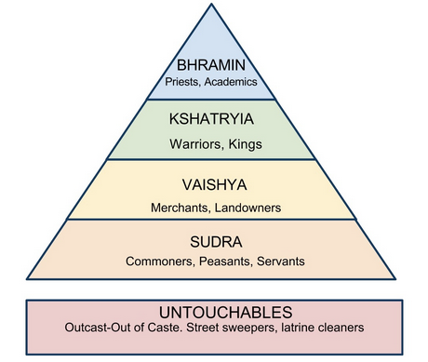

1. What are the central ideas of Hinduism?

* **Caste system – organized society, divided it into 4 different social classes (Brahmins, Kshatriyas, Vaisyas, Sudras – and the “Untouchables”)**
* **Reincarnation – cycle of rebirth (karma, dharma & moksha)**
* **Karma – idea that your good & bad deeds influence your next life**
* **Dharma – idea that it is better to fulfill your own destiny than try to be something you’re not (better to be a bad warrior if that’s your caste than the best baker)**
* **Moksha – Freedom from the cycle of rebirth by achieving enlightenment (to become one with the Brahman, the great world soul.)**

1. What are the origins of Buddhism?

* **Siddhartha Gautama - Hindu prince who became aware of the suffering in the world. Abandoned his life of luxury to reform Hinduism in order to solve the problem of suffering. Became enlightened through meditation and was renamed the Buddha, which meant “teacher”**

1. 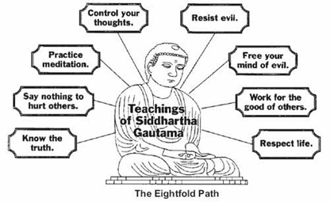What are the central ideas of Buddhism?

* **Caste system creates suffering.**
* **4 Noble truths**
  1. **All life is suffering.**
  2. **Suffering is caused by desire.**
  3. **To end suffering, end desire.**
  4. **To end desire, follow the Eightfold Path.**
* **By following the Eightfold path, people could free themselves from the cycle of reincarnation and achieve nirvana in this life, even if they were a low caste.**
* **Most converts come from untouchables**
* **Spreads to East Asia through travel, trade, & missionaries**

**China Builds a Bureaucracy**

**Learning Goal 4:** Describe the basic beliefs of Legalism, Daoism, and Confucianism and explain how classical Chinese leaders created a strong centralized government based on Confucian teachings.

1. Explain the basic characteristics of Legalism, Daoism, and Confucianism.

* 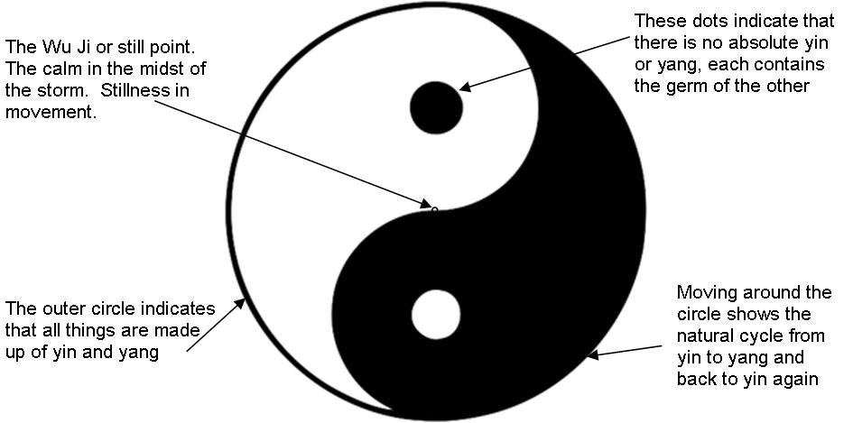**Legalism – Qin dynasty belief that people are naturally wicked and required harsh laws to force them to behave morally.**
* **Daoism – Humans can achieve peace and happiness by living simply, in harmony with nature.**
* **Confucianism – Humans are basically good, and can achieve a peaceful society by being obedient to those in authority.**
  + **Confucius believed in 5 relationships:** 
    1. **ruler-subject**
    2. **parent-child (filial piety)**
    3. **husband-wife**
    4. **elder brother-younger brother**
    5. **elder friend-younger friend.**

1. 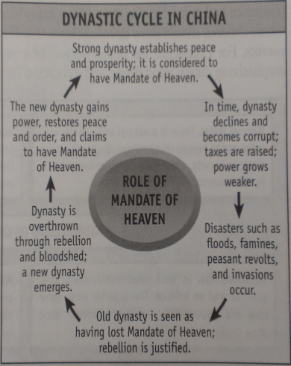Explain the ideology of the Mandate of Heaven.

* **The Mandate of Heaven explained why a dynasty had the right to rule China. If a dynasty lost the MOH, bad things began to happen and the dynasty was overthrown. When a new strong family emerged from the chaos, they were said to have gained the MOH.**

1. What contributions did the Zhou Dynasty add to Chinese history?

* **Belief in the dynastic cycle and the mandate of heaven.**

1. How did the ruler of the Qin Dynasty implement Legalism and how did they help to unite China?

* **Passed harsh laws, punished/killed anyone who disagreed with them.**
* **Built roads, started Great Wall of China, created a strong central administration, and created a single monetary system ($$).**

1. How did the Han Dynasty develop a strong centralized bureaucracy?

* **Created civil service exams – tests to see if a person was qualified to work in the government; this was a change from people being govt. officials because of their family/personal connections.** 
  + **Allowed lower class people to improve their lives through hard work and study.**
  + **Guaranteed to have educated people in govt.**

**Rome Creates a Republic**

**Learning Goal 5:** Describe how the Roman republic was structured, identify the legal influences of the Roman Empire and explain how Christianity developed out of the Jewish tradition and spread throughout the Roman Empire.

1. How was the Roman republic structured?

* **Separate branches of government – executive (Consuls), legislative (Senate), and judiciary (Judges) – same as United States now.**
* **Senate – had the most power**
  + **created laws**
  + **controlled military & economic policies**
  + **elected by Roman citizens**
* **Dictators – chosen by Senate in times of crisis. Had absolute power over laws and army, but only for a short period of time.**

1. How did Roman law influence European and U.S. law?

* **Twelve Tables – Roman law code**
  + **Rule of law – all citizens are equal under the law**
  + **Innocent until proven guilty**
  + **right to face your accuser**

1. What are the origins of Christianity?

* **Jesus of Nazareth – born Jewish in Israel. Believed to be the “Son of God”, and to have died on the cross to redeem mankind’s sins. His apostles spread his teachings after his death.**

1. Why and how did Christianity spread throughout the Roman Empire?

* **Paul – brought Jesus’ teachings to gentiles (non-Jewish people).**
* ***Pax Romana*** 
  + **Good roads & common language of Roman Empire allowed Christianity to spread easily.**
* **Message of equality was important to common people/slaves within the Roman Empire.**
* **Constantine – Roman emperor that allowed Christianity to be a legal religion in Rome.**

**Greatness and Collapse**

**Learning Goal 6:** Identify what advances were made in mathematics, science, and technology during the classical period and explain how classical Rome and Han China collapsed.

1. What are the major mathematical advances of the classical period?

* **Greece – value of *pi* (3.14)- Archimedes, geometry (Euclid), Pythagorean theorem A2 + B2 = C2**
* 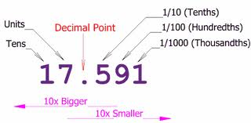**India – concept of zero, decimal system, number system used today, basic geometry, circumference of the earth**

1. What are the major scientific advances of the classical period?

* **Greece –star charts and leap year calendar, circumference of the earth (Eristhosthanes)**

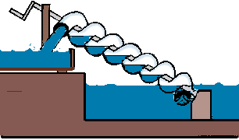

1. What the major technological advances of the classical period?

* **Greece –architecture (Dorian, Ionic & Corinthian columns), philosophy, deductive logic (Aristotle), Archimedes Screw**
* 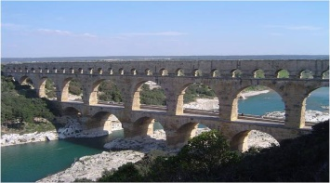**Rome – Aqueducts, roads, engineering/monumental buildings, invention of concrete**
* **China – Paper (Han), Windmills, Great Wall (Qin), Grand canal**

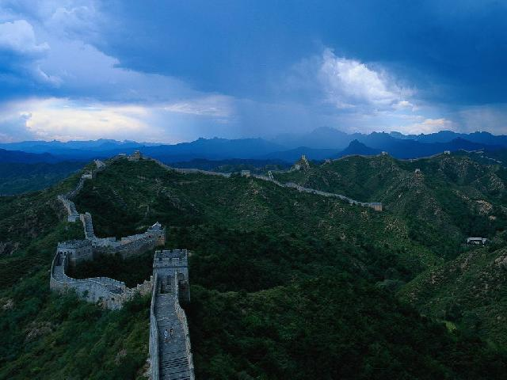

1. Why did Roman Empire and Han Dynasty fall?

* **Grew too big**
* **Plagues decrease labor force (less soldiers, workers, & people to pay taxes)**
* **Govt. corruption**
* **Weak emperors**
* **Barbarians invasions**

1. What is different about the fall of the Roman Empire and the Han Dynasty?

* **China eventually regains power because of Dynastic Cycle**
* **Roman Empire is divided into East (Byzantine Empire) and West.** 
  + **Western Roman Empire falls apart, no longer an empire.**