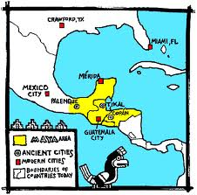
The Maya: 500 BCE-900 CE

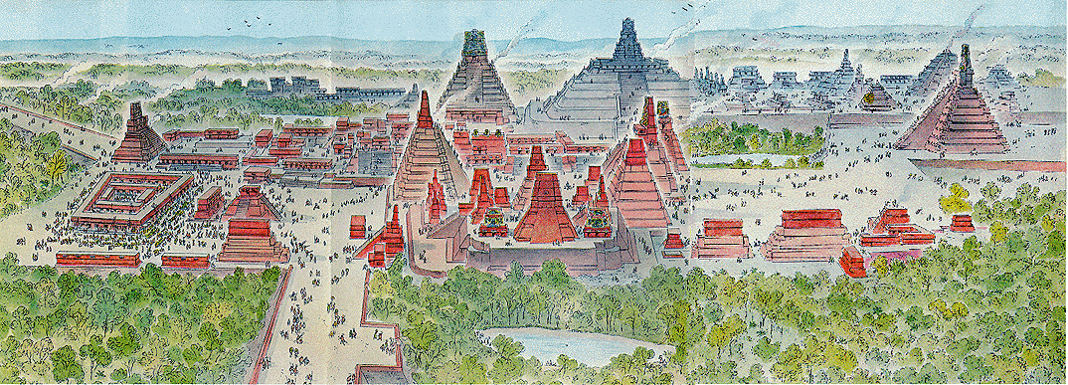
Not much is known about life in Mesoamerica before the Maya. There was a previous civilization known as the Olmec (1220-400BC) who probably influenced the Mayan practice of building large pyramids as temples and the Mayan religion.

Mayan civilization centered around their religion. The Maya were polytheistic, and built cities as trade centers and as areas to worship their gods. The cities were made up of pyramid shaped temples where priests lived to perform religious rituals. Religious ceremonies mainly involved sacrifices. The Maya believed that the gods required nourishment from human beings. While sacrifice often involved foodstuffs, the bulk of sacrifice involved some form of human sacrifice. The majority of this human sacrifice was blood-letting, in which a victim, usually a priest or royalty, voluntarily pierces a part (or parts) of their body, usually their tongue, ears, lips, or genitalia and "gives" blood to the gods. A few ceremonies demanded the living heart of a victim, in which case the victim was held down and his heart ripped out and then burned. The Maya rarely practiced this extreme form of sacrifice, using prisoners captured in war as sacrificial victims.
The Mayan city of Tikal

The Maya were not centrally organized politically. In general, their cities were independent city-states, each ruled by a king or queen. Neighboring cities were often at war with each other, as rulers fought to gain land for their cities and power for themselves. Trade between city-states was an important aspect of Mayan life – cities often traded jade and obsidian for cotton, rubber, and cacao beans.Mayan cities housed anywhere from a couple of thousand people to as much as 50,000 to 100,000. The Mayan civilization had well defined social classes of nobility, priests, warriors, farmers, and slaves.

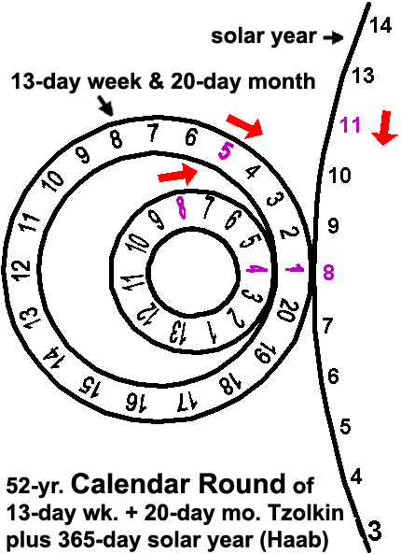
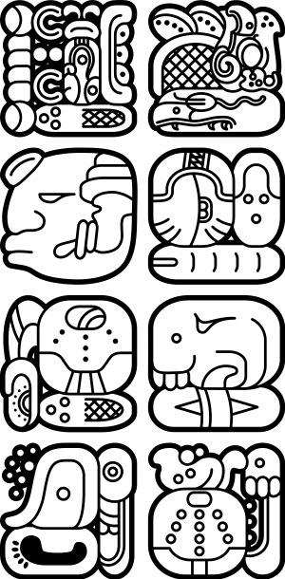
Maya population was generally small. The main reason for this is that Mesoamerica is dominated by rain forests. In order to grow food the Maya had to practice slash-and-burn agriculture. In slash and burn agriculture, the Maya would cut down a swath of forest, burn the downed trees and plants for fertilizer, and then cultivate the plot of land. The Maya did not employ sophisticated fertilization techniques to preserve the soil, so the plot of land would be exhausted in two to four years. What all this means is that it takes an immense amount of land to support a family, since land was used up so rapidly to feed a small group of people. Among the Maya, it probably required at least seventy acres of land to support every five people. The main crop they grew was maize (corn). Maize was an a-“maizeing” crop because it could feed more people than other crops, which was especially important considering that they had such little land to use. If slash and burn agriculture didn’t make farming hard enough, Pre-Columbian civilizations did most of their labor by hand. European farmers used oxen and horses to plow their fields. The Americas had no large animals to do work for them, so humans had to do all the labor.

Mayan agriculture required accurate predictions of time and the weather to be able to farm in the rain forest. So the Maya developed three different calendar systems. In combination, these calendars made the Maya the most accurate time keepers in history. Their calendars were so accurate they were only off by one day every 6000 years. Our calendar system is of course off 1 day every 4 years, which is why we have to have a leap year. The Maya developed a number system using the number “0,” just like the Indians. They also developed an advanced writing system which was the only one developed in the New World.
Mayan Hieroglyphic Writing

The Maya began to abandon their cities in the 9th century due to over-use of the surrounding lands for agricultural production.

The Aztec Empire: 1100’s CE – 1521 CE
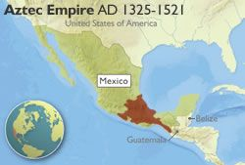
The people that became known as the Aztec were originally a group of hunter-gatherers who migrated to the Valley of Mexico around the 12th century CE. According to their legends, their god would show them an eagle with a snake in its beak perched on a cactus and they should then settle down there. The Aztecs saw this sign on an island in Lake Texcoco and built their capital city of Tenochtitlan there in the 14th century. The Aztecs were highly influenced by a previous civilization known as the Toltecs – who were very warlike. This influence would lead the Aztecs to conquer much of modern-day Mexico and form the Aztec Empire. At its peak, almost 5 million people were part of the Aztec Empire. They mainly let conquered peoples rule themselves, but demanded they be paid tribute in human sacrifices, food, and wealth. If local rulers refused to pay the tribute, Aztec armies would destroy the town.
Chinampa farming in Tenochtitlan
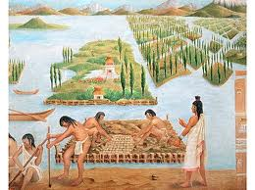
Like the Maya, the Aztec’s main crop was the a-“maizeing” crop corn. Because Tenochtitlan was on a lake, the chinampa method of agriculture was used. Flat reeds were placed in the shallow areas of the lake, covered with soil, and then farmed. In this way, the Aztecs reclaimed much of the lake for agriculture. A large part of the city's population were farmers; at the height of its population roughly 100,000 – 300,000 people lived there and at least half of the population would leave the city in the morning to go farm and return in the evening.

Like the Maya, the Aztecs developed extensive trade routes all over Mesoamerica and used cacao beans as a form of currency.

Aztec society was rigidly organized. At the top of the social order was the king. Below the king were priests, who interpreted calendars and performed religious ceremonies. Warriors were also part of the upper class. Not part of the upper class, but still important to the Aztec were merchants and artisans. Farmers and slaves made up the lowest classes of people. However, social class was not permanent, for one could rise into the pilli (nobility) by virtue of great skill and bravery in war, showing how important battle was to the Aztecs. The Aztecs also required boys and girls to attend school until they were 15.

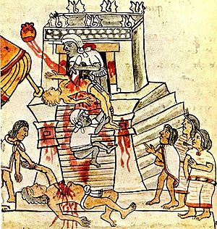
The overwhelming aspect of Aztec religion was their practice of human sacrifice. Mesoamerican religious beliefs believed that the gods gave things to human beings only if they were nourished by human beings. Sacrifices involved prayer, offerings of food, sports, and even dramas. The Aztecs practiced all of these sacrifices, including blood-letting. But the Aztecs also developed the notion that the gods are best nourished by the living hearts of sacrificed captives; the braver the captive, the more nourishing the sacrifice. This theology led to widespread wars of conquest in search of sacrificial victims both captured in war and paid as tribute by a conquered people.

We can successfully reconstruct Aztec human sacrifice with a high level of accuracy. Some sacrifices were very minimal, involving the sacrifice of a slave to a minor god, and some were very spectacular, involving hundreds or thousands of captives. Aztec history claims that one king sacrificed 20,000 people after a military campaign. No matter what the size of the sacrifice, it was always performed the same way. The victim was held down by four priests on an altar at the top of a pyramid or raised temple while an official made an incision below the rib cage and pulled out the living heart. The heart was then burned and the corpse was pushed down the steep steps; a very brave or noble victim was carried down the steps. While human sacrifice was the most dramatic element of Aztec sacrifice, the most common form of sacrifice was voluntary blood-letting which occurred at every religious function. Such blood-letting was tied to rank: the higher one was in social or priestly rank, the more blood one had to sacrifice.
Aztec human sacrifice
So, why did the Aztecs sacrifice thousands and thousands of innocent victims, while the Maya rarely did? The Aztec believed that the world was controlled by gods that were constantly fighting each other over whether to destroy or preserve the world. Obviously, the Aztecs wanted to make sure that the gods who wanted to save the world won. By performing so many sacrifices, the Aztecs hoped that the “good” gods would be strengthened and defeat the “bad” gods, thereby saving the world.

The Aztecs had an accurate 365 day calendar. This calendar was tied into their religious system. They believed that every 52 years, the destruction of the world may occur, so it was vitally important to sacrifice to the gods to help stave off this destruction.

The Inca
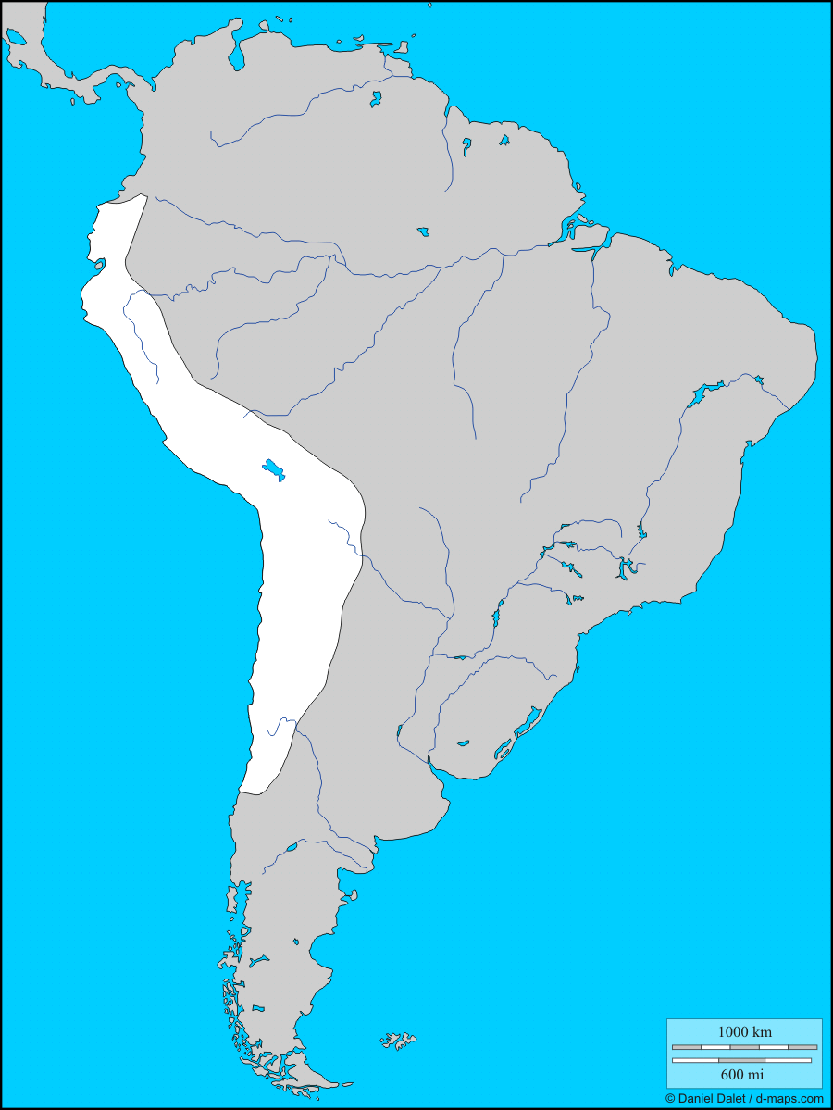

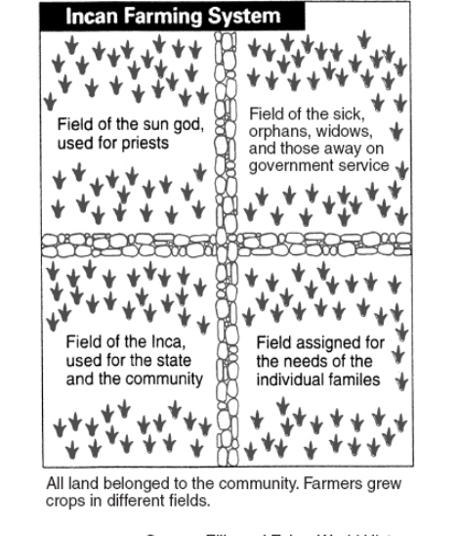
Around the 15th century, the Inca conquered a large empire in South America that stretched all along the western coast of the continent along the Andes Mountains. At its largest, the Incan Empire had a population of around 12 million. As they conquered new areas, the Inca would remove old leaders and replace them with leaders who were loyal to the Inca Emperor.
Inca

Incan society was divided into several classes. At the top was the Emperor, or “Sapa Inca.” The Sapa Inca was believed to be descended from the sun god, so he ruled with complete authority. The mummies of dead kings were kept in the capital city and worshipped. Other groups in the upper class were government officials and priests. The lower class was made up of artisans, farmers, and servants. They were forced to wear only plain clothing and the amount of goods they could own was limited. Common people were also required to “pay” a labor tax called the mita. Women could pay the mita by doing things like weaving cloth for the army, while men worked on government-owned farms, in mines, or built roads.

The Incan government had complete control over the economy of the empire. There were no merchants and no markets for trade. Instead, government officials were responsible for distributing goods throughout the empire. This kept the army supplied, as well as made sure the old and sick were taken care of. Any extra food or goods were stored in government warehouses to be used in emergencies.

Agriculture was tough business in the Andes Mountains. The Inca actively set about carving up mountains into terraced farmlands – carving steps into the mountains that people could farm on. The Inca cultivated corn, potatoes, cotton, tropical fruits and also raised llama for food and wool. The Inca took advantage of the vertical climate zones of the Andes Mountains to grow different crops at different elevations. Their agricultural system relied on cooperation and planning and was designed to provide food for all members of society.
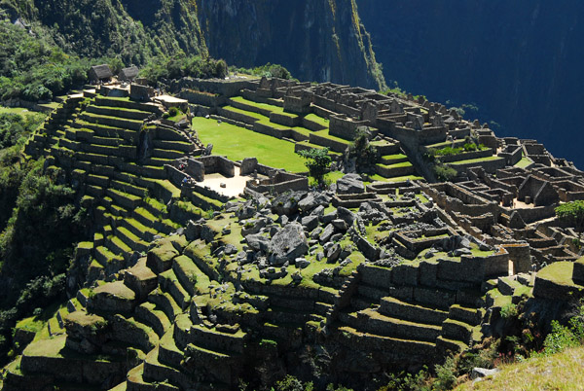
Terraces & Ruins of Machu Picchu
Of all the civilized people of the Americas, the Inca were the most brilliant engineers. They performed amazing feats of fitting gigantic stones together, and designed mind-numbingly huge earth-drawings that still exist today. The Inca built massive forts and buildings with stone slabs so perfectly cut that they didn't require mortar—and they're still standing today in near-perfect condition. Without the use of metal tools, the Inca created elaborate cities high in the mountains, such as Machu Picchu.

They also built an elaborate road system throughout the mountains from Ecuador to Chile. Mountains are notoriously hard to travel through, so the Inca dug tunnels and built bridges between the mountains – all without modern technology! This vast network of roads that stretched all across the continent united their empire, allowing the king to communicate across the vast distances of his empire. Like the Maya and Aztecs, the Inca used their road system to support their trade networks as well. The Inca road system facilitated a vertical trade network in which crops grown in the different vertical climate zones were distributed throughout the empire.

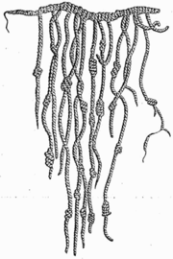
Quipu

Another technological invention of the Incans was the use of quipu – devices made of strings and knots of llama hair that allowed them to keep track of large numbers. With quipu, Incan officials could keep track of their large population (take a census) and record food supplies and production. Unlike the Maya and Aztec, the Inca had no written language.

