**Persian Empire**

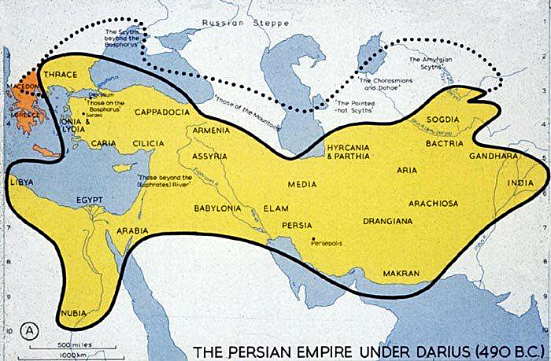**Essential Question**: How were the Persian Rulers able to build and rule a large empire?

How would the Royal Road enable a ruler to maintain power in the empire?

|  |  |
| --- | --- |
| R |  |
| O |  |
| A |  |
| D |  |
| S |  |

**The Rulers of Persia**

**Cyrus “The Great”**

* 550 BC - _____________________ neighboring __________________
* ______________________ Genius who used overwhelming ____________________
* ______________________ towards ______________________ peoples
* ______________________ local _____________________ and _______________________
* 550 BC – Allowed ______________ to return to ____________________________

**Darius “The Great”**

* 522BC – Took _________________
* ___________________________________ Government
* _____________________&________________________ In the empire
* _____________________ The Persian Empire by ___________ miles
* Could _______ conquer ____________________

**Essential Question:** How were Persian rulers able to build and rule a large empire?