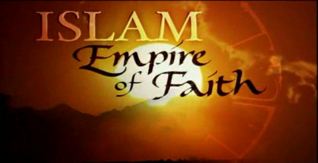
Empire of Faith Viewing Guide
Name:
Class Period:
Solidarityharmony of interests and responsibilities among individuals in a group, especially as manifested in unanimous support and collective action for something
Introduction
- How many times do prayer calls happen each day? ______________

- What type of scholars reclaimed the ancient wisdom of the Greeks while Europe was in the “dark ages”?_____________
Mohammed : The Messenger
- Where (geographically) was Muhammad born?

- What type of culture was Arabic culture (how did they tell stories)?

- Oral culture
- Pictorial Culture
- Musical Culture
- Scientific Culture

- Why is the Kaaba important?

- It was the house of Muhammad
- Idols to Bedouin Gods were kept there
- It is where livestock was herded
- It was a valuable water source

- What happened in the cave in Mecca that was the defining experience of Muhammad’s life?

- Is Islam a Polytheistic religion, or a Monotheistic religion?

- What did Muhammad’s followers call themselves?

- Why did the tribal leader want to remove Muhammad from Mecca?

- What is the hijra?

- The journey from Medina to Mecca
- The journey from Jeruselem to Medina
- The journey from Mecca to Medina
- The journey from Mecca to Yathrib

- Muhammad’s main goal was to bring _____________ and _____________ with his message.

- While spreading Islam did Muhammad challenge the beliefs of other faiths?

- What is the first pillar of Islam?

- What revelation did Mohammed receive in Medina?

- What did Muhammad do to the people of Mecca after the city fell to siege?

- Embraced the Meccan people
- Got revenge for the battle against him
- Forced them all to migrate to Medina
- Forced them all to convert to Islam or die

- What did Mohammed do to the idols in the Kaaba? What was it symbolic of?

- How did the Islamic army treat conquered people?

- What is the significance of the Dome of the Rock to Muslims?

- The location of the Kaaba
- Where all Muslims face during prayer
- Where Abraham almost sacrificed his son
- The location of Muhammad’s death

- What happened in Medina after the death of Muhammad?

- What was the divergence of opinion on how they should choose a new leader
  - Shite

  - Sunni

