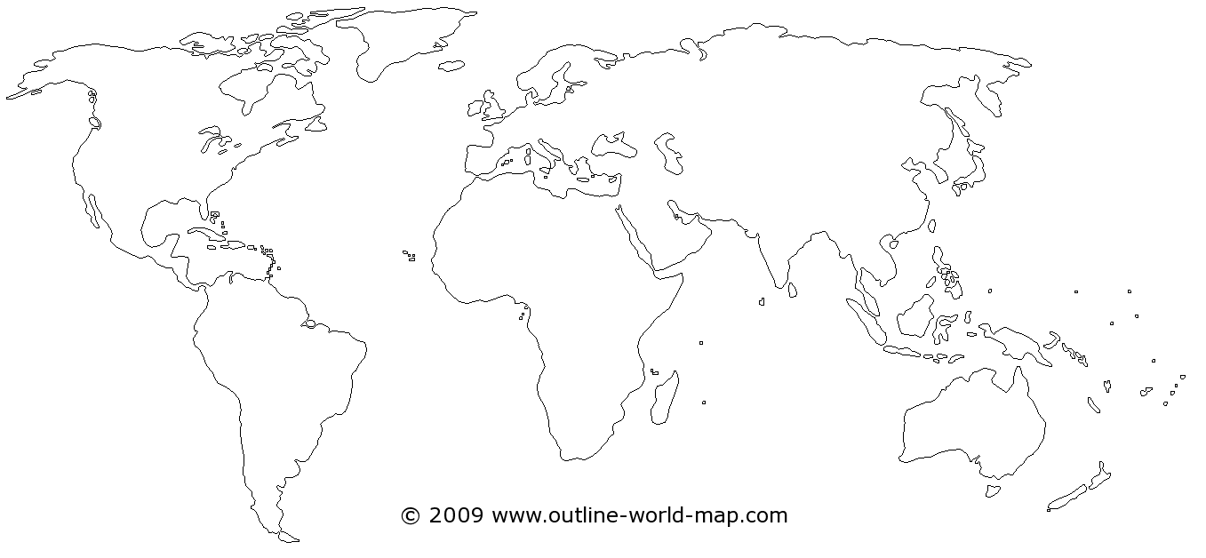

Products and Ideas that Spread Along the Silk Routes

East African Trade Products

Products and Ideas that spread with the Trans-Saharan trade routes

Legend

**Medieval Trade Systems**

Legend

Products and Ideas that Spread along the Silk Routes

Products and Ideas that spread with the Trans-Saharan trade routes