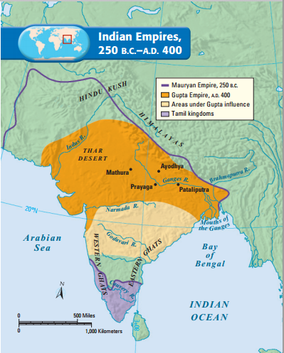**Asoka Promotes Buddhism**

Asoka became king of the Mauryan Empire in 269 B.C. Under Asoka’s rule the Mauryan Empire would reach its height. At first, he followed in his grandfather Chandragupta’s footsteps, waging war to expand his empire. During a bloody war against the neighboring state of Kalinga, 100,000 soldiers were slain, and even more civilians perished.

Although victorious, Asoka felt sorrow over the slaughter at Kalinga. As a result, he studied Buddhism and decided to rule by the Buddha’s teaching of “peace to all beings.” Throughout the empire, Asoka erected huge stone pillars inscribed with his new policies. Some edicts guaranteed that Asoka would treat his subjects fairly and humanely. Others preached nonviolence. Still others urged religious [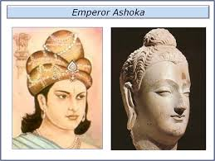](http://www.google.com/imgres?q=ashoka+the+great&safe=active&rls=com.microsoft:en-us:IE-SearchBox&biw=1280&bih=627&tbm=isch&tbnid=f5Wp7X0soyIJdM:&imgrefurl=http://emperors-shirshak.blogspot.com/2011/02/ashoka.html&docid=MkmnIdo6d-k5uM&imgurl=http://2.bp.blogspot.com/-vbWwsJtCC2A/TVqi_HOVVMI/AAAAAAAAAAk/nVyPg2Jtlr8/s320/image13.png&w=639&h=480&ei=uoowUtbLJZGo9gSs4oHwBg&zoom=1&iact=hc&vpx=586&vpy=330&dur=1094&hovh=195&hovw=259&tx=112&ty=135&page=3&tbnh=144&tbnw=214&start=57&ndsp=31&ved=1t:429,r:68,s:0,i:288)toleration—acceptance of people who held different religious beliefs. Through his practices, Asoka was instrumental in spreading the faith of Buddhism to millions of others across Central Asia.

Asoka had extensive roads built so that he could visit the far corners of India. He also improved conditions along these roads to make travel easier for traders, Buddhist pilgrims, and his officials and to improve communication in the vast empire. For example, every nine miles he had wells dug and rest houses built. This allowed travelers to stop and refresh themselves. Such actions demonstrated Asoka’s concern for his subjects’ well-being. Noble as his policies of toleration and nonviolence were, they failed to hold the empire together after Asoka died in 232 B.C. The Mauryan Empire ended about 100 years later.