River Valley Civilizations
Name:

Classical Empires
Characteristics of Empires | China
India | Rome
Greece | Persia
Post Classical
Western Europe Byzantine Empire

Rise & Spread of Islam

Islam in Spain
Islam in India

Tang & Song China

Mongols

Contact & Connection
Ottoman Empire

Pre Columbian Civilizations

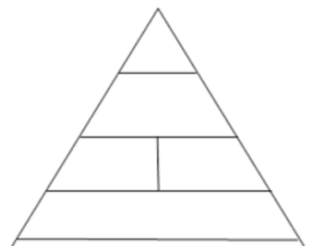
European Exploration

Indian Ocean Trade

