Name: _____________________________________ Period: ____
Foundations of Civilizations Test Review

- Describe the Neolithic Revolutions & its effects on people.

- List and describe the characteristics of civilization.
Characteristic | Description/Explanation

- How did physical geography impact the early civilizations?

- Describe the characteristics of the major River Valley Civilizations and their contributions/inventions.
Huang-He (Yellow River):

Indus:

Mesopotamia (including Sumer):

Nile (Egypt):

- What was unique about the Fertile Crescent?

- What was the impact of Hammurabi’s Code? Why was it important?

- Be able to locate each River Valley Civilization on a world map.
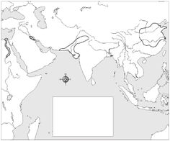

A
D
C
B

- Compare and contrast Hammurabi’s Code and the Ten Commandments.

- Explain Judaism and what made it unique at that time.

