**Industrial Revolution**

Why England?

|  |  |  |  |
| --- | --- | --- | --- |
| **Political** | **Economic** | **Geographic** | **Social** |
|  |  |  |  |

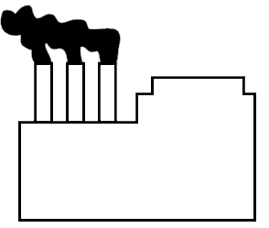

**Factory System**

**Cottage System**