**LG1 The Cold War**

Describe the causes and effects of the Cold War and explain how the Korean War, Vietnam War, and the arms race were associated with the Cold War

**Results of WWII**

|  |
| --- |
| **VE Day🡪**  **VJ Day🡪**  **United Nations🡪** |

**Global Divide/ Competing Ideologies**

**Super powers: ______________________________________ vs. ________________________________________**

|  |
| --- |
| **USSR Goals USA Goals** |

|  |  |  |
| --- | --- | --- |
|  | **Western Democracies** | **Soviet Communism** |
| **Political System** | * **Citizens ______________ leaders** * **Citizens have the right to form political parties** | * **USSR – ______________________________________________________**   + **The only political party allowed** |
| **Individual Rights** | * **Basic civil rights**   + **Free speech**   + **Freedom of press**   + **Freedom of religion** | * **_____________________________________** * **_____________________________________** * **_____________________________________** * **_____________________________________** |
| **Economic System** | * **Economic freedom** * **People & corporations can own land & businesses** * **Goods & services provided for a profit** | * **No private property** * **_____________________________________________** * **State-owned collective farms** |

|  |
| --- |
| **The Iron Curtain🡪** |
| **Division of Germany🡪**  **The Berlin Wall and Airlift:🡪** |
| **Arms Race🡪** |
| **Policy of Foreign Containment:** |

|  |  |  |
| --- | --- | --- |
| **Communism in China:** | **Korean War:** | **Vietnam War:** |

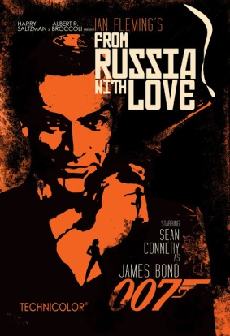

|  |
| --- |
| **Effects of the Cold War:**  **How did the Cold War affect art & literature?** |