Napoleon Bonaparte’s Effects on Europe
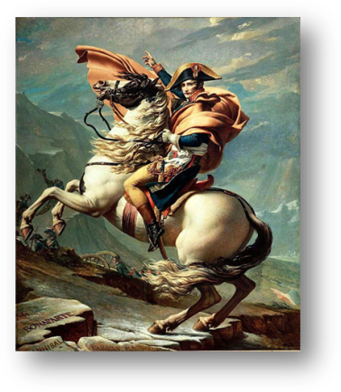
Perhaps the aspect of Bonaparte's life that most captivated people was his humble beginnings. Here, like some Greek tragedy, is the story of the rise from the bottom of a strong-willed and brilliant man whose flaws eventually cause him to fall from power. Although his parents were not extremely wealthy, they were nobility. So he had the luxury of attending good schools. While there, the other noble children would make fun of him for being poor, making him resent the whole system of nobility for his whole life and lead him to become a big supporter of the French Revolution.

Napoleon was a military officer by the time that the French Revolution started and he worked hard to protect the Revolutionary government. He was ruthless (he once punished a town that resisted his forces by gathering the citizens in the town square and firing his cannons at them) and brilliant – soon becoming a general.

In 1799, Napoleon enacted a coup against the Revolutionary government and became a virtual dictator of France. The rule of Napoleon was in many ways an astonishing success. Napoleon pursued the dream of centralized power with an efficiency that hadn't been seen since the days of Louis XIV. He centralized the administration of the country and made all parts of that administration directly under the national government's control; although he truly believed in equality for all men, he was a true follower of absolutist principles. France was no democracy under Napoleon, he controlled the government just as totally as King Louis XIV the Sun King had done. He also did not make democracies in the nations that he conquered. He placed all of his brothers and sisters (he had many) onto the thrones of Europe. His older brother he made king of Spain for example, even though his brother was an inept ruler.

The Napoleonic Code (1804)
Of all the achievements of Napoleon’s rule, the historically most significant was the creation of a new law code for France, called the Napoleonic Code. This legislation sought to make French law apply to the nation as a whole consistently. Before Napoleon, each region in France had a different set of laws – there was no consistency for being accused of crimes 3 miles down the street from each other. So Napoleon decided to fix that with a single law code that would be based on the most fundamental ideas of the Enlightenment. The Code was based on two ideas: that all men are equal under the law (but not women) and all people have a right to property.

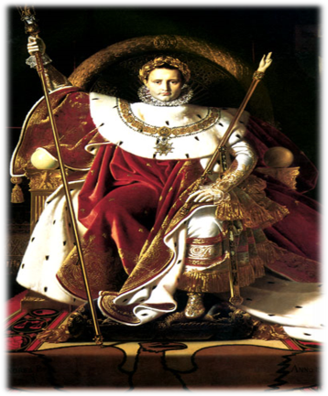
To promote equality, the code eliminated all noble privileges from the laws, including tax laws so nobles had to pay taxes just like anyone else. Napoleon also had a policy of promoting officers and soldiers based on their ability, not their birth. He also made the highest-ranking jobs in his government to be open to all men of talent. Napoleon was extremely proud of this accomplishment – he truly believed that all men deserved the same chances as any other. Napoleon however did not think women deserved the same rights as men and his law code kept women inferior to men. He once said, “In France, women are considered too highly. They should not be regarded as equal to men. In reality, they are nothing more than machines for producing children.”

The protection of one’s property was also a vital Enlightenment idea – after all, America rebelled against Britain just because they charged us a few low taxes. The code spelled out various contractual laws to ensure the importance of private property.

As Napoleon conquered other nations, he spread the Napoleonic Code as he went. As other nations adopted the Code, they also acquired the Enlightenment and French Revolution ideals that the code was based on. For example, during the Napoleonic Wars, serfdom was abolished throughout Central Europe. Napoleon ended the practice that serfs and peasants owed their lords mandatory labor and fees or taxes. The idea that all men are created equal was spreading everywhere!

The Rise of Nationalism throughout Napoleon’s Empire

Another profound effect of Napoleon’s rule was the rise of Nationalism – intense pride and devotion to one’s country. As Napoleon’s armies conquered country after country, he caused the people in those nations to feel intense patriotism as they lived under foreign rule. His conquering of the Holy Roman Empire awakened German nationalism – which will directly impact European history for the next 2 centuries, ultimately culminating in the creation of Germany and two World Wars. Before Napoleon, Germany had always admired French rationalism, language, and culture - almost more than their own. Now, in reaction to being conquered by these French foreigners, German intellectuals began turning to their own language, folklore, and heritage as their inspiration – Germans began thinking of Germany as one united nation. They coined the term Volksgeist – or the national character of a nation based on the spirit of the common people. They said that each nation had its distinct Volkgeist and Germany’s should be allowed to be expressed without French domination.

Napoleon’s Fall from Power
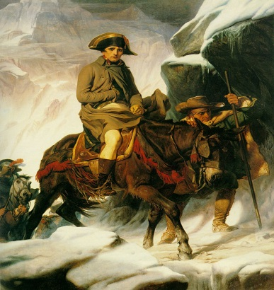
Despite all his victories in Europe, Napoleon was faced with two problems that prevented him from creating a single European empire. The first was the survival of Great Britain. Britain had the strongest navy in the world, and was able to beat Napoleon at sea every time he tried to invade. After a crushing defeat at the Battle of Trafalgar, Napoleon abandoned the idea of invading Britain and turned to the Continental System to weaken Britain economically. The Continental System was meant to keep Britain from being able to trade with Europe, but it too was a failure. Instead, the Continental System weakened Napoleon’s hold on his European allies. Russia, in particular, was the most unhappy, and withdrew from the alliance. Napoleon was left with no choice but to invade.

In June 1812, Napoleon led a Grand Army of over 680,000 men into Russia. His plans depended on a quick defeat of Russian armies, and if the armies had ever faced each other in battle, Napoleon would have been victorious. The Russians, however, refused to fight a pitched battle, and instead retreated back through the countryside, burning farms and villages as they went to keep Napoleon’s army from being able to find food. This strategy is known as the scorched earth policy, and it was extremely effective. Napoleon and his armies finally reached Moscow in September, only to find the city abandoned and deliberately set on fire. Without supplies or shelter from the coming winter, Napoleon was forced to retreat from Russia. The winter conditions were so severe that only 40,000 men of his original army escaped out of Russia.

This disastrous defeat led other European states to rebel and attack while France was weak, and Napoleon was defeated in April of 1814. He was sent into exile on the island of Elba, off the coast of Italy. After escaping Elba, Napoleon managed to return to France for one last time, but was defeated finally at the Battle of Waterloo. He died broken and alone in exile on the island of Saint Helena in 1821.

The Congress of Vienna

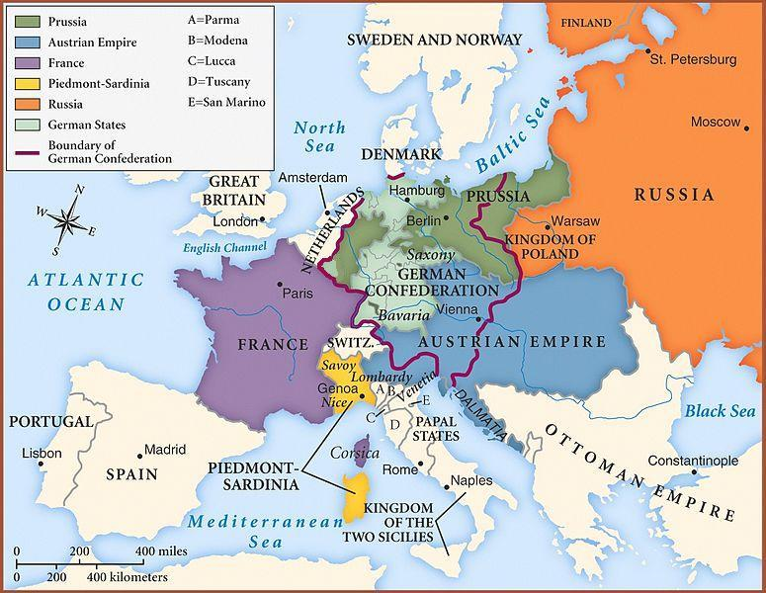
The last effect of Napoleon’s reign over Europe was what he caused the other countries of Europe to do. European leaders all met at the “Congress of Vienna,” where they then decided what to do with Europe now that Napoleon and the French Revolution had been defeated. Their main goal was to maintain a “balance of power” in Europe. Napoleon and France had ruled most of Europe for 15 years – he had almost conquered all of Europe. The nations at the Congress of Vienna wanted to prevent France or any other country from threatening to take over again. So they re-drew the map of Europe with that goal that no single country could dominate the others, and thus hopefully, there would be peace since no single nation could be aggressive without risking the wrath of the other nations. For example, to prevent France from being too powerful again in the future, the members of the Congress created a series of "buffer" nations around France, such as the Netherlands, that would keep France from expanding again.

The other goal of the Congress of Vienna was to restore things to how they were before the French Revolution. They were thoroughly in favor of monarchy and rejected any republican or democratic governments in Europe. They installed Louis XVIII, the brother of Louis XVI, as King of France and made a commitment to prevent any other revolutions from overthrowing any other monarchy in Europe.

