What changes in Europe led to the Renaissance?
Renaissance means _________________
Rebirth of the Classical World
Cause 3:
Cause2:
Cause 1:
Effect:

Art
 | What details do you see? | Who do you think he was?
 | What is the man doing? | Why would Myron have created this piece?
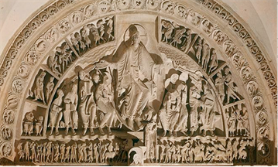 | What details do you see? | How is he different from the others?
 | Who is depicted in the center? | Why would this have been created?
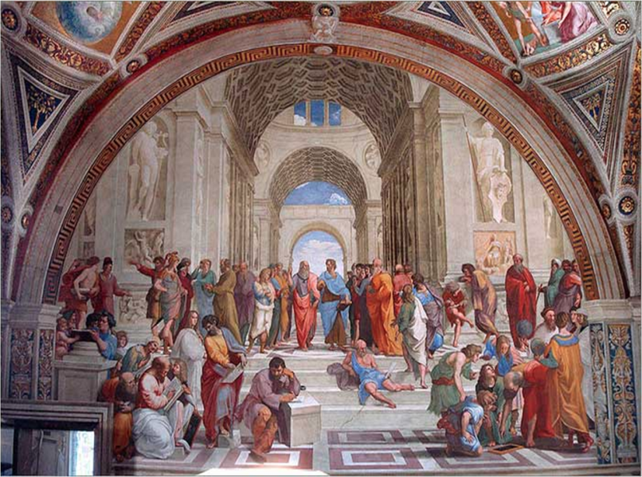 | What details do you see? | How is this piece of art different from the others?
 | Who is depicted in the center? | Why would this have been created?
 | Classical | Medieval | Renaissance
Purpose of the Art
Style Characteristics

Travel and Commerce
Cause 3:
Cause2:
Cause 1:
Effect:

Growth of City-States
Cause 3:
Cause2:
Cause 1:
Effect:

Humanism
Cause 3:
Cause2:
Cause 1:
Effect:

