**River Valley Civilizations Map**

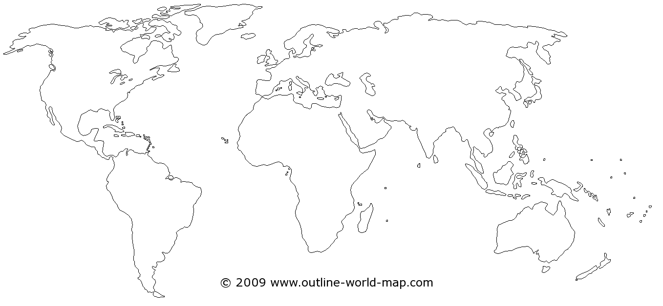

Key

Nile River Valley Mountains

Mesopotamia Rivers

Indus River Valley Cities

Yellow River Valley Deserts

Mesoamerica & Andes