Civilian Life

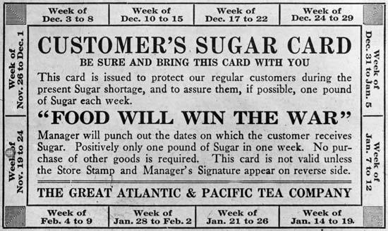

An American sugar ration card.

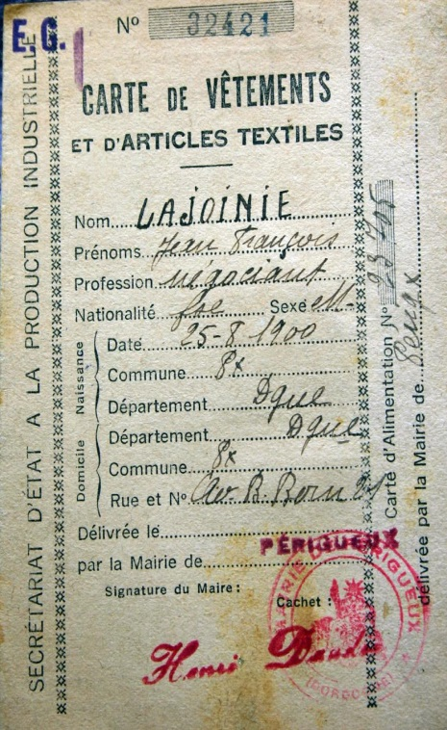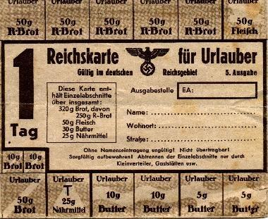

An unused German daily food ration card

**Translation for German Ration Card**

Tag: Day

Brot: Bread

Fleisch: Meat

Nahrmittel: Flour or grains

A French clothing ration card for Jean Francois Lajoinie

Propaganda for Civilians in Britain & the USA



