Station 5: Resisting the Nazis
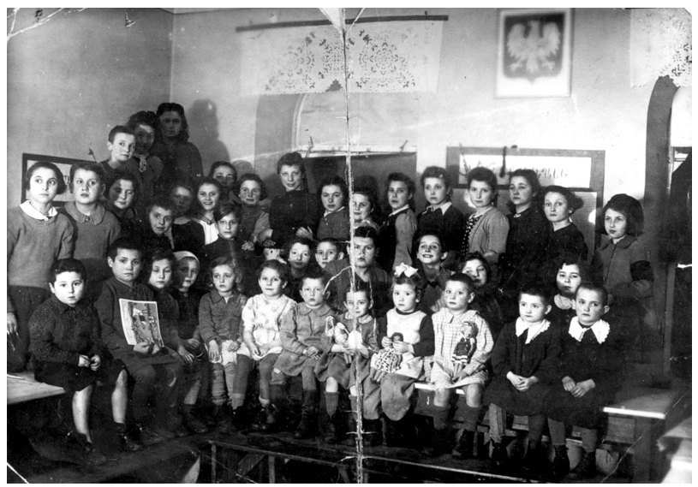
DOCUMENT A Hidden Children
This photograph shows Jewish children who were successfully hidden in a Catholic orphanage in Poland during World War II posing just after the war ended.

DOCUMENT B
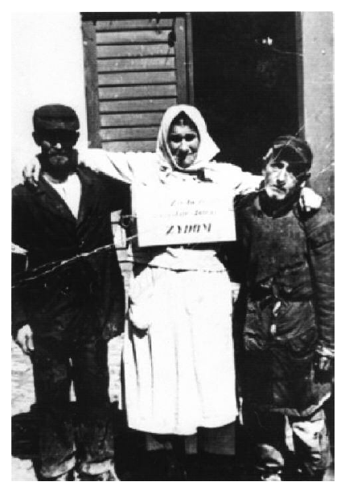
Spectators watch as a Polish woman is led through the town square by two Jewish men (note their armbands). The sign around her neck states “for selling merchandise to Jews” in Polish. She is supposedly being taken to an execution site. In Poland, the consequence for a non-Jew helping a Jew in any way was imprisonment or death. This photo is from after 1940.

-Zydowski Instyut Historyczny Naukowo-Badawczy, courtesy of the United States Holocaust Memorial Museum Photo Archives

DOCUMENT C
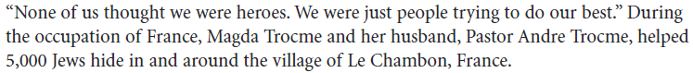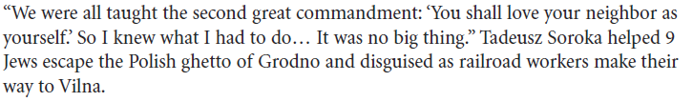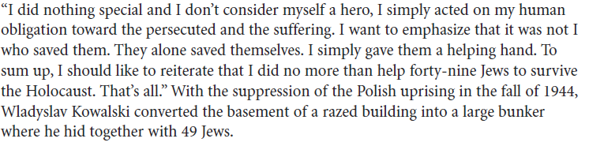

Conclusion
- Do you think people who hid or otherwise helped Jews during the war are heroes? Explain in at least 3 sentences.

