Unit 3: Post-Classical Era Exam Review KEY
2016-2017
- What impact did Christianity and the Roman Catholic Church have on Medieval Europe?
Culturally unified the region, political and social stability, provided education

- What are the characteristics of Roman Catholicism and Eastern Orthodoxy?
Characteristic | Roman Catholicism | Eastern Orthodoxy
Leader | Pope | led by Patriarch, Emperor was a God-anointed ruler
Beliefs | Western Europe | Eastern Europe
Language | Latin | Greek, also created Cyrillic Script to translate bible into other Slavic languages
Priests | Pope appoints officials, Priests were celibate, shaved beards and head | Priests were able to marry, grew long beards

- What is Justinian’s Code of Laws? Why is it important?
Code of laws used by Justinian in The Byzantine Empire. It is used as a model for legal codes in Europe

- What was the result & the impact of the Battle of Tours?
Charles Martel stopped the advance of the Moors, if he hadn’t Western Europe may have become part of the Islamic Empires and therefore may still have practiced Islam today

- How was architecture of Medieval Europe influenced by Christianity? What did cathedrals emphasize?
Gothic: flying buttresses, very tall cathedrals emphasized the magnificence of God.

- Describe and explain the impact of the following people: Thomas Aquinas, Clovis, and Charles Martel.
Thomas Aquinas: Scholasticism, believed people should balance reason and faith
Clovis: Ruler of Franks, converted to Christianity and brought Catholicism to Gaul (Modern day France)
Charles Martel: stopped Muslim advances at the Battle of tours, Leader of Franks

- What was the impact of the fall of the Roman Empire?
No central government, Feudalism developed because people needed protection, cities and trade declined

- What is feudalism and what are its characteristics?
Political System based on exchange of land for loyalty and service
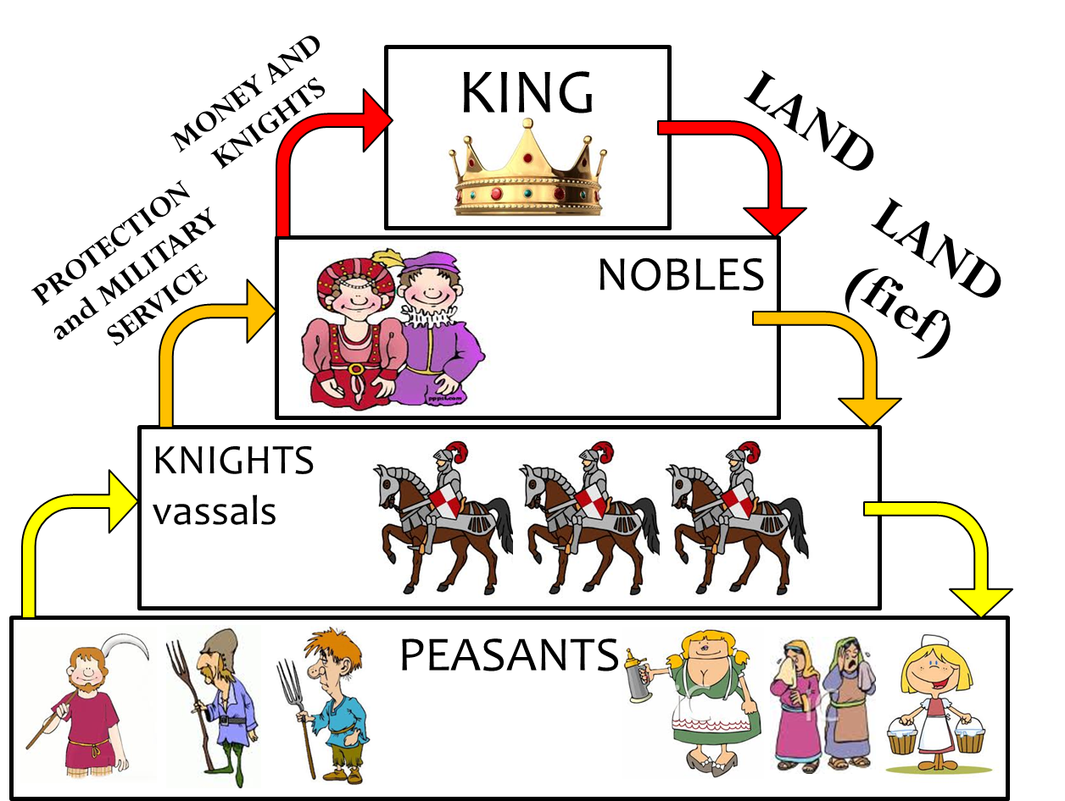

- What is Manorialism and what are its characteristics?
Economic system during feudalism. Manor is self-sufficient; everything that is necessary for life was created on the manor.

- What are the historical origins of Islam?
Muhammad was the Prophet of Islam, he gathered followers. Muhammad tried to convert people in Mecca, he had to flee the city. Eventually he began conquering lands in the Middle East. After his death, there was a division in Islam over who should be the next Caliph (leader)

- What are the central ideas of Islam?
Monotheistic, Qur’an is the holy book
5 Pillars:
• Shahadah: Muslim profession of faith
• Salat: pray 5 times each day
• Zakat: alms (or charity) tax
• Sawm: fasting during the month of Ramadan
• Hajj: pilgrimage to Mecca

- Why was the Islamic Empire able to spread so quickly?
Neighboring areas were weak from fighting & Muslims were very tolerant of the people they conquered

- Describe the significance of the spread of Islam.
Politically and culturally unified North Africa, Arabia, Persia and Asia Minor (and parts of modern day Spain). Governments were based on religious law

- Describe the mathematic, scientific, artistic/architectural, and scholarly achievements made by the Muslim world.
Mathematic- spread numerals developed by Indians, expanded algebra
Scientific- medical encyclopedia
Artistic/Architectural- developed calligraphy and arabesque due to the ban on use of human figures
Scholarly – preserved Greek and Roman writings in libraries such as House of Wisdom and brought them back to European scholars

- What were the political, economic, and cultural characteristics of Tang and Song China?
Political – Chang’an was center of government and trade, Confucianism was revived and Buddhism lost influence, built the Great Wall to protect against invasion
Economic – advanced seafarers, Grand Canal facilitated trade, used paper money and letters of credit, trade along Silk Road brought new ideas
Cultural – Footbinding became common in upper class women

- List and describe technological developments of Tang and Song China.
Compass – Navigation
Porcelain – used to make pottery
Gunpowder – for military and also used to make fireworks
Movable type – printing press

