Name:____________________________________________________________ Date:_______________________________ Period:____________

Unit 10 Identifications
Mao Zedong  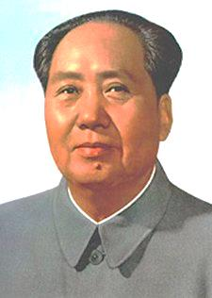 | Who:  Significance:
Chiang Kai-shek  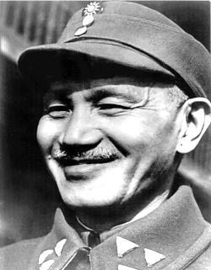 | Who:  Significance:
Ronald Reagan  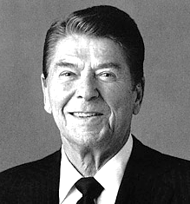 | Who:  Significance:
Mikhail Gorbachev  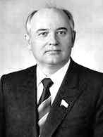 | Who:  Significance:
Pope John Paul II  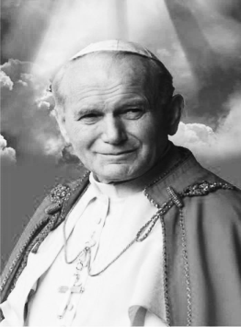 | Who:  Significance:
Gen. Douglas MacArthur  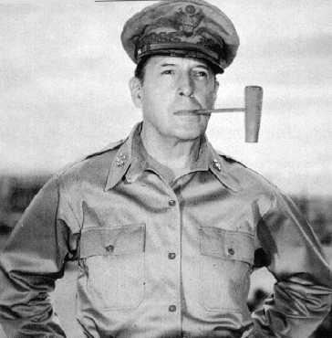 | Who:  Significance:
Kim Il Sung  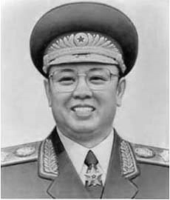 | Who:  Significance:
Ho Chi Minh  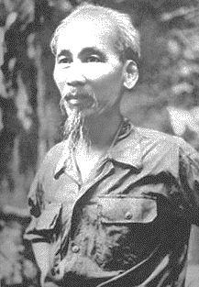 | Who:  Significance:
Boris Yeltsin  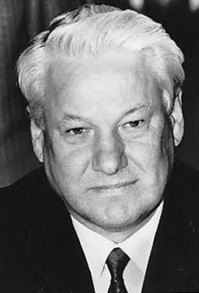 | Who:  Significance:

