[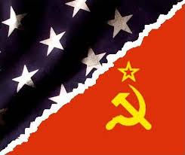](http://www.google.com/imgres?start=195&safe=active&rls=com.microsoft:en-us:IE-SearchBox&biw=1280&bih=627&tbm=isch&tbnid=QkPyLDYmNQiyQM:&imgrefurl=http://historyofrussia.org/what-year-did-the-cold-war-start/&docid=Euy0nrlNt7mphM&imgurl=http://historyofrussia.org/wp-content/uploads/2011/08/Cold-War-Flags.jpg&w=409&h=343&ei=83ZnUZ2MCYvRqwHfl4GgDg&zoom=1&iact=hc&vpx=660&vpy=169&dur=132&hovh=206&hovw=245&tx=140&ty=105&page=9&tbnh=151&tbnw=185&ndsp=28&ved=1t:429,r:13,s:200,i:43)

**The Cold War**

At the end of World War II, the United States and the Soviet Union were left as the world’s two major powers – the United States had vast economic power and the atomic bomb; the Soviet Union had the Massive Red Army. They became known as Superpowers. During World War II, these two countries had been allies, despite the fact that their political, economic, and social systems were quite different.

After the war, each Superpower attempted to extend its influence, quickly leading to a “**Cold War**” – emerging first in Europe and then in Asia, Latin America, and Africa. The Cold War was “cold” only in the sense that the two Superpowers never confronted one another directly in open warfare. But their global competition led to crises, conflicts, and proxy wars on every continent, dominating world events for the next 45 years.

The roots of the Cold War lay in the competing ideological systems of the Western democracies and Soviet Communism. While Western nations hoped to spread democracy and free enterprise, Soviet leaders promoted the spread of Communism. In order to understand the Cold War one must understand the fundamental differences between the two systems.

In Western democracies citizens elect representatives and national leaders and people have the right to form and associate with political parties of their choosing. Citizens have basic rights, such as freedom of speech, freedom of the press, and freedom of religion. Economic freedom allows people and corporations to own land and businesses and businesses provide goods and services in order to make a profit.

Under Soviet Communism, the Soviet Union was a dictatorship controlled by Communist Party leaders and the Communist Party was the only political party allowed to operate. Ordinary citizens had few rights and the government controlled all radio, television, and newspapers. Secret police arrested all critics of the government and the practice of religion, which was called the “opiate of the masses”, was discouraged. Under Soviet Communism many forms of private property were abolished and the government controlled all production through state ownership and central planning. Additionally, private farms became state-owned collective farms.

Soviet leader Joseph Stalin, who viewed the Soviet Union as a "socialist island", stated that the Soviet Union must see that "the present capitalist encirclement is replaced by a socialist encirclement." As early as 1925, Stalin stated international politics as a bipolar world in which the Soviet Union would attract countries gravitating to socialism and capitalist countries would attract states gravitating toward capitalism.

**The Iron Curtain, NATO, & the Warsaw Pact**

During the opening stages of World War II, the Soviet Union annexed several countries that were ceded to it by the Nazi-Soviet Pact. These included eastern Poland, Latvia, Lithuania, Estonia, part of Finland, and eastern Romania. Other Eastern European territories that were liberated from the Nazis such as East Germany, Poland, Bulgaria, Hungary, Czechoslovakia,Romania, and Albania were also brought under Soviet control. These countries were collectively referred to as the **Eastern Bloc**. Stalin felt that the Soviets had the right to control the Eastern Bloc to act as a buffer to protect Soviet security from Western aggression.

The Soviet-style regimes that arose in the Bloc not only reproduced Soviet command economies, but also adopted the brutal methods employed by Joseph Stalin and Soviet secret police to suppress real and potential opposition.When the slightest stirrings of independence emerged in the Bloc, Stalin's strategy matched that of dealing with domestic pre-war rivals: they were removed from power, put on trial, imprisoned, and in several instances, executed. In Asia, the Red Army had overrun Manchuria in the last month of the war, and went on to occupy the large portion of Korean territory located north of the 38th parallel.

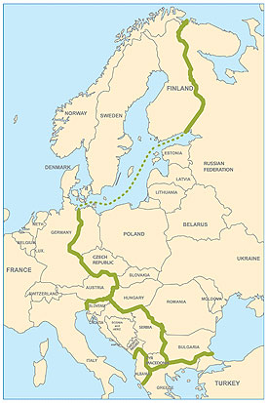 British Prime Minister Winston Churchill was concerned that, given the enormous size of Soviet forces deployed in Europe at the end of the war, and the perception that Soviet leader Joseph Stalin was unreliable, there existed a Soviet threat to Western Europe. In 1946, Churchill announced that an “**Iron Curtain**” had descended across Europe. This “Iron Curtain” separated the democracies of Western Europe from the Soviet controlled Eastern Bloc. Trade, travel, and communications between Eastern and Western Europe were cut off and Eastern Bloc governments were forced to create Communist economies and follow policies dictated by the Soviet Union.

This map shows the “Iron Curtain” dividing Eastern and Western Europe

In 1949, the United States, Canada, and ten Western European countries formed the **North Atlantic Treaty Organization (NATO)** to protect Western Europe from Communist aggression. With NATO, the United States pledged to defend Western Europe with its arsenal of nuclear weapons. Soviet leaders responded in 1955 by creating the **Warsaw Pact** with the Eastern Bloc. When Hungary tried to drop out of the Warsaw Pact, Soviet forces moved in to crush the uprisings.

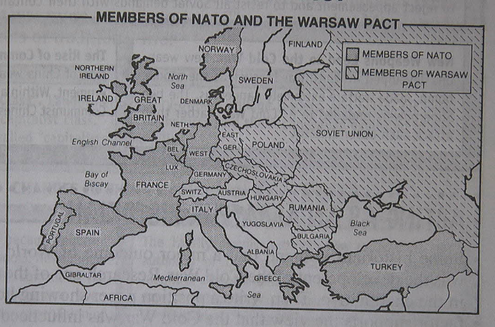

[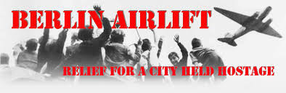](http://www.google.com/imgres?safe=active&rls=com.microsoft:en-us:IE-SearchBox&biw=1024&bih=595&tbm=isch&tbnid=T8mI3KAut_XRzM:&imgrefurl=http://mason.gmu.edu/~jlemza/Final%20Assignment%20Prelude.html&docid=IKBfCoJERC24wM&imgurl=http://mason.gmu.edu/~jlemza/img/Berlin-Airlift-16K.gif&w=780&h=254&ei=WDlnUYz4LuWsyAHxuoHQBg&zoom=1&iact=hc&vpx=519&vpy=336&dur=411&hovh=128&hovw=394&tx=155&ty=51&page=2&tbnh=88&tbnw=270&start=17&ndsp=23&ved=1t:429,r:32,s:0,i:184)

[http://bits.wikimedia.org/skins-1.20wmf1/common/images/magnify-clip.png](http://en.wikipedia.org/wiki/File:C-47s_at_Tempelhof_Airport_Berlin_1948.jpg)

**Berlin Airlift**

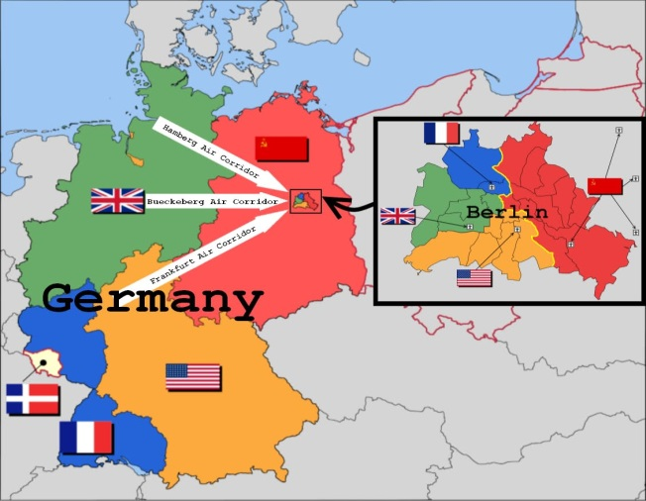 Following Germany’s surrender on May 7, 1945, Soviet, British, American, and French troops occupied all of Germany. Each country was responsible for administering their portion of the country. In 1948, the Western allies took the first steps to merge their zones of occupation in Germany. As part of the economic rebuilding of Germany, Great Britain, France, and the United States merged their areas into a federal governmental system and began to re-industrialize the country.

Shortly thereafter, Stalin instituted the Berlin Blockade (June 24, 1948 – May 12, 1949) by blocking all Western highway and railroad links to the city of Berlin, preventing food, materials and supplies from arriving into the city. This was one of the first major crises of the Cold War. The United States, Britain, France, Canada, and several other countries began the massive "Berlin Airlift", flying in food and supplies to West Berlin on an around the clock basis for 11 months until the Soviets admitted defeat and lifted the blockade.

In 1949, the three Western zones of occupation were officially merged into a new independent state, known as the Federal Republic of Germany, more commonly referred to as **West Germany**. Stalin responded by turning the Soviet zone into the German Democratic Republic, or **East Germany**.

**Berlin Wall**

By the 1950's control of emigration from Eastern European countries was a problem for the Soviet Union. Travel restrictions were more easily enforced where previous borders had existed, but this was not the case in West Germany and East Germany. Hundreds of thousands of East Germans annually immigrated to West Germany through a "loophole" in the system that existed between East and West Berlin, where the four occupying World War II powers governed movement.

[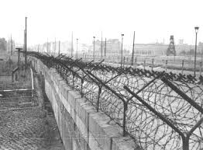](http://www.google.com/imgres?safe=active&rls=com.microsoft:en-us:IE-SearchBox&biw=1024&bih=595&tbm=isch&tbnid=mlBG2WazkzQoDM:&imgrefurl=http://www.calwatchdog.com/2012/10/12/california-concentration-camp/berlin-wall/&docid=-hD6T38EH11hBM&imgurl=http://www.calwatchdog.com/wp-content/uploads/2012/10/Berlin-Wall.jpg&w=398&h=293&ei=ATpnUdCeNOyAygHD1YCYAg&zoom=1&iact=hc&vpx=563&vpy=46&dur=396&hovh=193&hovw=262&tx=107&ty=97&page=2&tbnh=141&tbnw=191&start=15&ndsp=20&ved=1t:429,r:33,s:0,i:187) The emigration resulted in a massive "[**brain drain**](http://en.wikipedia.org/wiki/Brain_drain)" from East Germany to West Germany of younger educated professionals such as doctors, lawyers, engineers, and educators, thereby leaving East Germany with an overall less educated population capable of filling professional positions. Nearly 20% of East Germany's population had migrated to West Germany by 1961. Eventually, to deal with the emigration issue, the Soviets built a wall between West Berlin and East Berlin, effectively closing the loophole. The **Berlin Wall** was referred to as the "[Anti-Fascist](http://en.wikipedia.org/wiki/Anti-Fascist) Protection Wall" by the Soviets, who argued that the wall was needed to stop the encroachment (intrusion) of the west.

**Arms Race**

The 1950’s and 1960’s were characterized by a Superpower race to develop superior weapons and defensive technologies. The extremely destructive nuclear weapons that were developed served as **deterrents**, preventing the Superpowers from attacking one another. This deterrence value led to the accumulation of huge stock piles of weapons and huge military expenditures on both sides. The large stockpiles of nuclear weapons held by the Superpowers guaranteed that if one side or the other ever launched a nuclear strike it would lead to **Mutually Assured Destruction**, or **MAD**, meaning that no matter who fired first both sides would be destroyed.

The quest for defensive technologies led to a space race between the Superpowers and the resulting technologies that have developed from the exploration of space. The United States and the USSR developed **Intercontinental Ballistic Missiles (ICBMs)**, long-range weapons that they could use to strike the territory of the other. In August 1957, the Soviets launched the first satellite, Sputnik, into outer space. The launch of Sputnik started the Space Race which resulted in new technologies and the exploration of space.

The **Nuclear Non-Proliferation Treaty (NPT)** was an agreement signed in 1968 by several of the major nuclear and non-nuclear powers that pledged their cooperation in stopping the spread of nuclear technology. Despite the signing of the NPT which tried to limit nuclear arms to China, Russia, US, Great Britain and France, proliferation of nuclear weapons continued. Eventually Israel, India and Pakistan developed nuclear weapons. Although the NPT did not ultimately prevent nuclear proliferation, it set a precedent for international cooperation between nuclear and non-nuclear states to prevent proliferation.

By the 1980’s the Superpowers began negotiations to reduce the amount of weapons each had and some treaties followed. Yet the idea of deterrence remains strong in the international community as nations like North Korea and Iran continue to develop nuclear capabilities.

