**Cold War Conflicts**

**The spread of Communism under Chairman Mao Zedong to China intensified the Cold War, as western powers like the United States feared that communism would spread from China to all of Southeast Asia. This idea was encapsulated in the “domino theory”, the belief that if one country falls to communism then neighboring countries will also fall, which led to US involvement in the Korean and Vietnam wars.**

**Korean War 1950-1953**

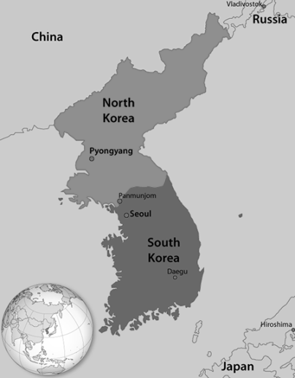After Mao Zedong’s victory in China, Western leaders feared Communism was on the march. Like Germany, Korea had been divided in 1945 into a Communist and non-Communist state. Korea was divided at the **38th parallel**, with the USSR occupying the North and US occupying the South. In 1950 **Kim Il Sung**, the Communist leader of North Korea ordered the invasion of South Korea in an attempt to unify the peninsula. President Truman and other Western leaders believed it was necessary to take a firm stance against Communism.

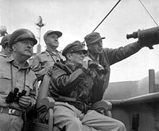Under a UN (United Nations) resolution, the United States and other countries intervened and forced the Communists back to North Korea. UN forces, led by **General Douglas MacArthur**, then invaded North Korea. When they approached the Chinese border, China itself intervened. General MacArthur thought of using nuclear weapons against China, but President Truman refused to consider this option. Instead, he removed General MacArthur from his command. In 1953, a compromise finally ended the war, leaving North Korea and South Korea divided exactly as they had been before the conflict began, at the 38th parallel. Over 1.2 million people died during the Korean War including more than 35,000 US troops. Importantly, the Korean War was the first time that US soldiers fought in integrated units.

General [Douglas MacArthur](http://en.wikipedia.org/wiki/Douglas_MacArthur), UN Command (seated), observes the naval shelling of [Incheon](http://en.wikipedia.org/wiki/Incheon) from the [USS *Mt. McKinley*](http://en.wikipedia.org/wiki/USS_Mount_McKinley_(AGC-7)), 10/15/1950.

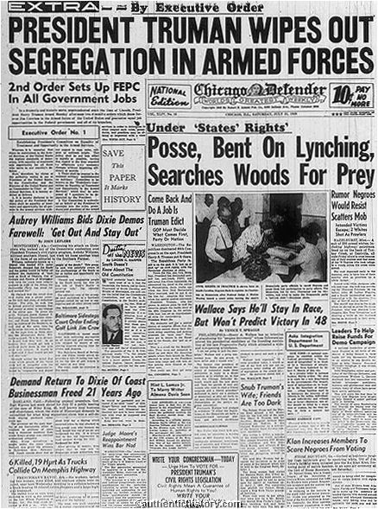In the years since the Korean War tensions have remained high between North Korea and South Korea as well as the US. The development of nuclear weapons by North Korea in 2006 intensified the division between the two countries as the international community imposed sanctions which isolate North Korea.

**Vietnam War 1954-1975**

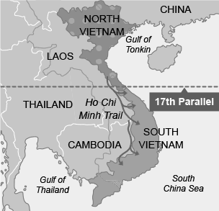Following World War II, Vietnamese nationalists fought to end French colonial rule and the territory was divided at the 17th parallel with communists controlling the North and the South establishing a democratic government. Nationalist leader **Ho Chi Minh** created a Communist state in North Vietnam, while South Vietnam established ties to the West. South Vietnam refused to hold elections to reunify the country, as previously agreed, arguing that elections in the communist North would not be free.

Communist guerrillas in South Vietnam, with the support of North Vietnam, instigated a civil war. The United States aided the South with monetary and troop support to help resist the spread of Communism. American leaders feared Southeast Asia countries might otherwise fall like dominoes. At first, American soldiers acted only as advisors to the South Vietnamese army. However, that changed when American combat troops were sent to Vietnam in 1964.

[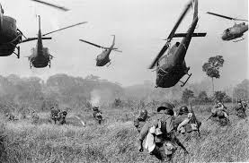](http://www.google.com/imgres?safe=active&rls=com.microsoft:en-us:IE-SearchBox&biw=1280&bih=627&tbm=isch&tbnid=Yqt0SSn4epFEiM:&imgrefurl=http://oneclickfun.blogspot.com/2011/12/vietnam-war-iconic-moments-rare-photo.html&docid=-4VSaVsexwI08M&imgurl=http://4.bp.blogspot.com/--RQZaKhi2KM/Tt8OlCKwHrI/AAAAAAAAIQA/WoBPCjQA3NU/s1600/Vietnam%2BWar%2BRare%2BPhotos%2B(13).jpg&w=700&h=459&ei=pJdnUaPlOsWg2QXfxYHYBA&zoom=1&iact=hc&vpx=516&vpy=137&dur=614&hovh=182&hovw=277&tx=114&ty=116&page=1&tbnh=152&tbnw=225&start=0&ndsp=17&ved=1t:429,r:3,s:0,i:91)Although the United States eventually used extensive bombing, had large numbers of helicopters, and sent in half a million troops, it was never able to turn the tide against North Vietnam. Meanwhile, in the US, due to ever increasing casualties (almost 60,000) support for the war was fading, generating a large anti-war protest movement. In 1973 American troops began to withdraw from Vietnam in an agreement reached in Paris. In 1975 the last US troops left Vietnam and the following peace agreement established a unified Vietnam under communist rule. This was a significant communist victory in the Cold War, in which a tiny country defeated a superpower, resulting in hundreds of thousands of deaths. An effect for America after the Vietnam War was fear of another Vietnam-like conflict, which has continued to shape US foreign policy.

