Name:____________________________________________________________ Date:_______________________________ Period:____________

Unit 11 Identifications
Mohandas Gandhi  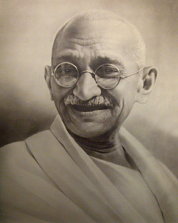 | Who:  Significance:
Osama Bin Laden  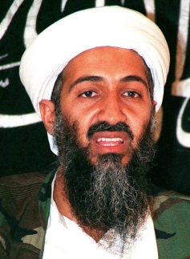 | Who:  Significance:
Pol Pot  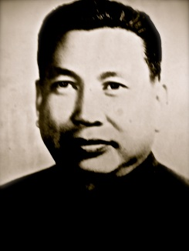 | Who:  Significance:
Nelson Mandela  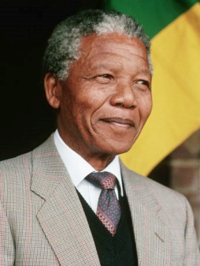 | Who:  Significance:
Oscar Romero  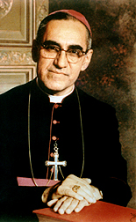 | Who:  Significance:
Natan Sharansky  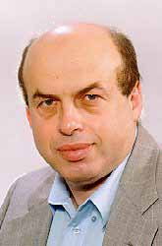 | Who:  Significance:
Mother Teresa  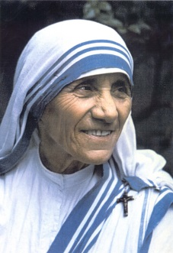 | Who:  Significance:
Indira Gandhi  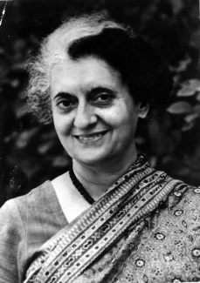 | Who:  Significance:
Margaret Thatcher  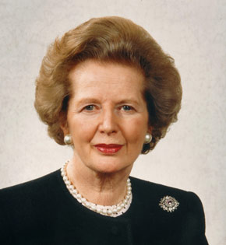 | Who:  Significance:
Golda Meir  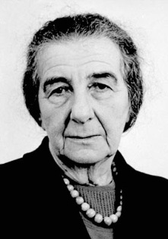 | Who:  Significance:

