Name: ________________________ Date: _______________________ Period: _________________
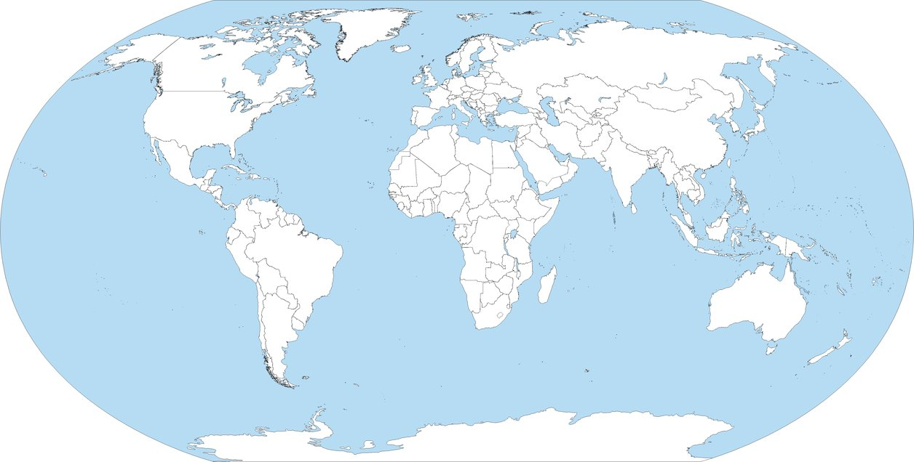
The Global Sneaker

Designing the Global Sneaker
- List the countries involved in this step of producing the global sneaker today. On the map, draw a blue dot in each of these countries.

- List three ways the design of sneakers has changed since the 1950s.

Locating Global Sneaker Materials
- List the countries involved in this step of producing the global sneaker today. On the map, draw a red dot in each of these countries.

- What materials are used to make the upper?

- What materials are used to make the midsole?

- How has the main material in a sneaker’s outer sole changed over time?

Manufacturing the Global Sneaker
- List the countries involved in this step of producing the global sneaker today. On the map, draw a green dot in each of these countries.

- Where did sneakers used to be made?

- What is Outsourcing and why have many sneaker companies moved to outsourcing sneaker manufacturing?

Distributing the Global Sneaker
- On the map, draw a typical sneaker distribution route from Asia to your state. DO NOT DRAW A STRAIGHT LINE FROM ASIA TO TEXAS! You should be following the steps and thinking about how things would be transported. (also remember that the Earth is ROUND!!)
- Describe how a typical pair of sneakers moves from a factory in Asia to an American consumer’s feet.

- How many miles does a sneaker have to travel from the factory to the consumer?

- Why might sneaker producers focus their sales efforts on the United States?

