The Rise of Fascism and Totalitarianism

The Great Depression
In the two decades following World War I, most of the world was swept up in economic depression. During the 1920’s and 1930’s, most nations attempted to cope with the problems of the post-war economy and uncertainties, with the U.S. stock market crash making the problem worse. The war ravaged nations of Europe had become dependent on financial help from America; however, after the U.S. stock market crash in 1929, the U.S. halted loans to foreign nations; making it much more difficult for Germany to repay its debts from WWI.
In the years after WWI, some European countries turned away from democracy towards giving power to dictators. In Germany and Italy, fascism, an extreme form of nationalism, gained support of the people. Fascism is a political philosophy that emphasizes extreme nationalism where the state is more important than the individuals. Germany was blamed for starting World War I and suffered the most sanctions with the peace settlement. Combined resentment and economic problems led the German people to support a fascist leader named Hitler and his fascist political party, the Nazis. This caused dissatisfaction and blame within Germany and Italy, giving rise to totalitarian dictators. These dictators would unite their countries around their leadership and push Europe towards another war.

The Rise of Totalitarian Dictators
In response to the economic disaster, some nations fell prey to totalitarian dictators. A combination of postwar nationalist resentment and economic hardship allowed military dictatorships to rise in Italy, Germany, and Japan. Additionally, dictatorships arose in other nations as well, such as Spain, the Soviet Union, and Latin America. Whether fascist or communist, totalitarian dictators controlled every aspect of life within their nation.

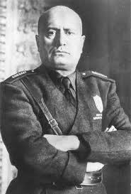
Mussolini and Italy
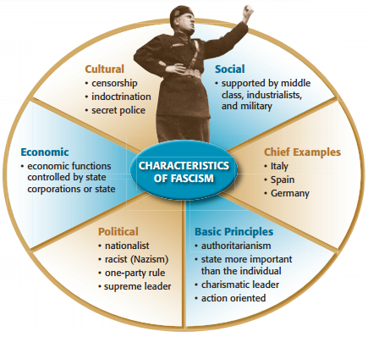
In Italy, Benito Mussolini, a newspaper editor and politician, led Italy’s Fascist party. This party was composed of dissatisfied war veterans, nationalists, and also people fearing the rise of communism and Stalin’s consolidation of power. Although Italy had been on the winning side of WWI, the country resembled a defeated nation. Italy’s economy was weak after WWI and faced food shortages, massive unemployment, violent labor strikes that were often led by communists, workers occupying factories, and peasants squatting on land. These problems created a crisis. Mussolini, or Il Duce, used this unrest to take control of Italy. He established a fascist totalitarian regime with his powerful speeches inciting nationalism among his people and promising to rescue Italy by reviving its economy and rebuilding its armed forces.
Fascism is characterized by dictatorship, centralized control of private enterprise, repression of opposition and extreme nationalism. Mussolini knew how to appeal to Italy’s wounded national pride, and played on their fears of economic collapse and communism. Mussolini promised order and stability and was not content to merely rule the nation, but with his secret police, the “Black Shirts”, Mussolini controlled every aspect of Italian life, crushing all opposition. He abolished democracy and outlawed all political parties except the Fascists, secret police jailed his opponents, and government censors forced radio stations and publications to broadcast or publish only Fascist doctrines.
Mussolini’s rise to power attempted to restore Italy’s position as a world power. In order to prove Italy’s military might, Mussolini ordered the invasion and conquering of Ethiopia, eventually contributing to WWII.

Hitler and Germany
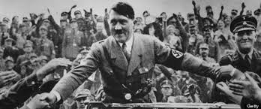
Italy was not the only nation to lose faith in capitalism and democracy. Germany turned towards an authoritarian leader as well. Many Germans were angry at the way WWI had ended. Germany had been forced to sign a humiliating peace treaty that put the blame for the war on Germany. It also had to pay huge reparations, give up land, and disband its army. The new government called the Weimar Republic, which had been forced to sign the Treaty of Versailles, was blamed by many German citizens for allowing Germany to be humiliated. Germany was also in an economic crisis in the years after the war due to the huge amount of reparations and the global depression. The German Fascist party called the Nazis rose to power in the 1920’s as a reaction to terrible economic conditions and resentment over the Treaty of Versailles. Adolf Hitler, also a powerful speaker and organizer, rose through the ranks to become the leader of the Nazi party.

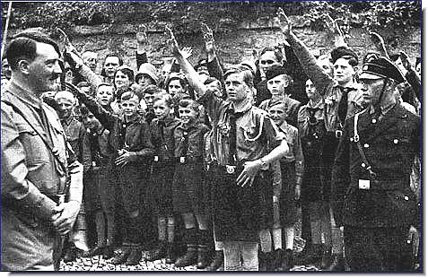
Similar to Mussolini’s fascism, Nazi Fascism was based on extreme nationalism. Hitler used the anger of the German workers to promote anti-Semitism, hostility and hatred towards the Jews, and enforcement of racial “purification.” Hitler also promoted national expansion and claimed that Germany needed more lebensraum, or “living space.” Hitler believed that in order for Germany to survive they must expand. Hitler planned on securing land and soil for his German people and would do so by force. Though elected democratically, Hitler was similar to Mussolini, in that once established in power he suppressed all opposition and ruled with fear.
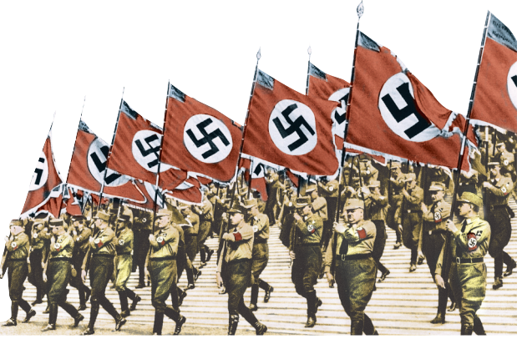
The Nazis moved to make all of Germany subject to the will of the Nazi party. They wanted to create a nation where everyone totally devoted themselves to the Nazi party and its ideas and they had several policies to encourage this. Through censorship and propaganda the Nazis controlled the press, books, radio, and movies. They sought to enforce the image of Hitler as the infallible leader of Germany. Hitler forced German children and teens to join the “Hitler Youth” – where they learned Nazi ideas and chanted songs about the glory of Hitler. The school system was designed to teach the Nazi ideology. Nazis told teachers how to teach their subjects and had students report on teachers who failed to do so. The whole society revolved around convincing people how great Hitler and the Nazis were. Like Mussolini, Hitler also had a secret police force called the SS. The SS were used to terrorize and eliminate enemies of the Nazis. The SS beat, arrested, killed, or sent to labor camps their enemies. They initiated mass arrests, persecuted Jews, and oversaw concentration camps.
To flex his power and demand for living space, Hitler broke the terms of the Treaty of Versailles and rebuilt his army, invaded the Rhineland and later the Sudetenland, and reunited with Austria (Anschluss) leading to WWII.

