Name:_______________ WWI Exit Ticket Explain the causes of World War I
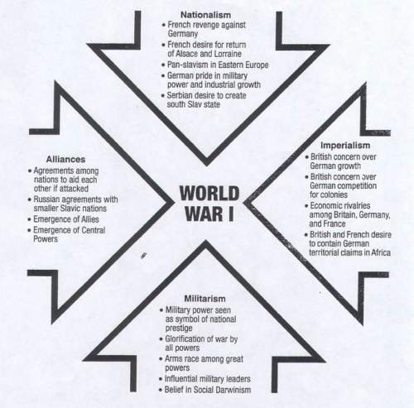 Name:_______________ WWI Exit Ticket Explain the causes of World War I

